5th COSMO General Meeting

Langen, Germany, 24-26 September 2003

Further Development of the LM Physics Package

Erdmann Heise
Deutscher Wetterdienst

Overview:

Multi-layer soil model

'Convective drizzle'

Convective gusts
1) The multi-layer soil model

a) Changes of the physics compared to the operational soil model:

(Some of these changes were suggested by ELDAS- and GME-tests)

- 7 layers, thickness first layer 1 cm

- Freezing/melting of soil water/ice

- New version of snow melting

- Gravitational drainage considered as lower boundary condition for water transport

- Aging of snow in the determination of snow albedo (ELDAS)

- Reduced snow density (ELDAS)

- Reduced snow albedo in forested areas, in preparation (GME)

b) GME2LM:

Changes were made to include the following interpolation between layers:

GME | LM
2 | 2
2 | 7
7 | 7

c) Present situation:

- 3-years runs using ELDAS-data (forcing by and comparison to observations)

- 1 year integrations with GME

- Single forecasts with LM

- Assimilation run with GME → technical problems

- No LM experiment yet because of missing initial data from GME assimilation run

2) 'Convective drizzle'

Operational at DWD since 09 July 2003

a) Result of parallel experiments:

 |  | Routine |  |  |  | Exp. 4026 |  | Exp. 4248
 |  | Jul 02 | Aug 02 | Nov 02 | Dec 02 | Jul 02 | Aug 02 | Nov 02 | Dec 02
RMSE | T | 2.16 | 2.07 | 2.11 | 1.38 | 2.13 | 2.04 | 2.09 | 1.37
RMSE | T_{d} | 2.91 | 2.59 | 2.08 | 1.08 | 2.88 | 2.57 | 2.06 | 1.07
RMSE | T_{max} | 2.49 | 2.10 | 2.09 | 0.26 | 2.43 | 2.08 | 2.09 | 0.26
RMSE | T_{min} | 1.99 | 2.05 | 2.28 | 0.30 | 1.99 | 2.05 | 2.28 | 0.29
RMSE | p | 1.36 | 1.17 | 1.92 | 0.15 | 1.36 | 1.18 | 1.88 | 0.15
RMSE | dd | 42.2 | 47.9 | 38.9 | 25.4 | 42.0 | 47.7 | 38.6 | 25.0
RMSE | ff | 1.99 | 1.77 | 2.42 | 1.83 | 1.99 | 1.77 | 2.42 | 1.82
% correct | N | 59.8 | 52.6 | 65.4 | 81.6 | 59.9 | 52.7 | 65.6 | 81.6
% correct | N_{CL} | 61.2 | 62.1 | 54.8 | 59.3 | 61.5 | 62.5 | 54.6 | 56.8
% correct | N_{CM} | 70.0 | 74.4 | 55.2 | 41.7 | 69.7 | 73.5 | 52.9 | 39.3
% correct | N_{CH} | 72.9 | 61.7 | 51.9 | 51.7 | 70.1 | 58.6 | 50.1 | 50.9
% correct | T | 68.9 | 69.9 | 71.6 | 86.5 | 69.5 | 70.8 | 72.0 | 87.0
% correct | T_{d} | 61.4 | 65.5 | 79.7 | 93.2 | 61.8 | 65.9 | 80.0 | 93.4
% correct | T_{max} | 61.1 | 65.7 | 68.5 | 87.2 | 62.4 | 66.9 | 69.4 | 87.2
% correct | T_{min} | 73.5 | 68.9 | 69.0 | 81.5 | 73.3 | 68.7 | 69.2 | 81.8
% correct | p | 99.5 | 99.6 | 96.3 | 100.0 | 99.6 | 99.5 | 96.5 | 100.0
% correct | dd | 62.9 | 58.3 | 66.4 | 83.3 | 63.5 | 58.5 | 66.8 | 83.3
% correct | ff | 89.7 | 91.8 | 85.5 | 92.9 | 89.9 | 91.8 | 85.5 | 92.9
TSS | RR>.1 | 46.1 | 41.5 | 43.7 | 40.3 | 47.7 | 42.3 | 43.8 | 38.0
TSS | RR>2 | 33.6 | 30.3 | 43.4 | 34.2 | 33.6 | 31.6 | 44.1 | 31.8
TSS | RR>10 | 15.5 | 18.4 | 25.6 | 0.0 | 14.1 | 19.3 | 25.2 | 0.0
Hits | RR | 65.8 | 65.3 | 60.3 | 61.8 | 67.6 | 66.9 | 59.2 | 58.5

Rather good success in the summer months, neutral to slightly negative in November. These results were available before start of operational use. Negative impact in December.

b) Investigation of a single case in June

In the morning of June 4, 2003 aviation meteorologists complained about widespread convection in south-western Germany (upper part of the following figure). No convective activity was present in the observations. A rerun using the suppression of 'convective drizzle' completely suppressed the convection (lower part of the following figure).
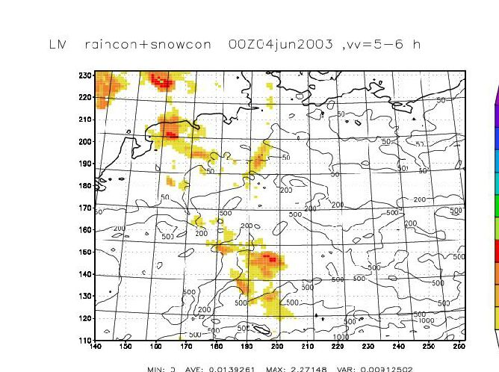
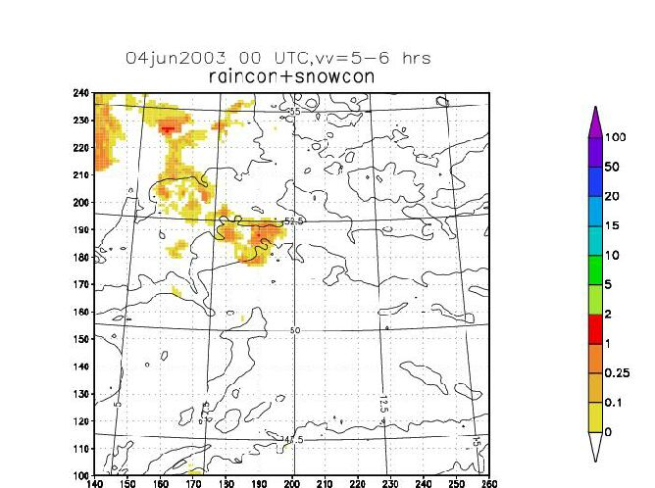

3) Convective gusts

Operational at DWD since 27 January 2003

$V_{\text{gust}}=\text{MIN}\left(\sqrt{α\int_{0}^{H}{2g(\frac{Δθ}{θ}+γ q_{r})+β V^{2}(H)}} , V_{\text{max}}\right)$Following Nakamura et al. (1996) the general formula is
with

V Windspeed
H Origin of the downdraft
Δθ difference of potential temperature environment - downdraft
q_{r} mixing ratio of rain

The following tuning parameters were used:

α = 0.2
β = 1.0
γ = 0.0
V_{max} = 30 m/s

Because of too high values of convective gusts in spring, since 06 May 2003 we use

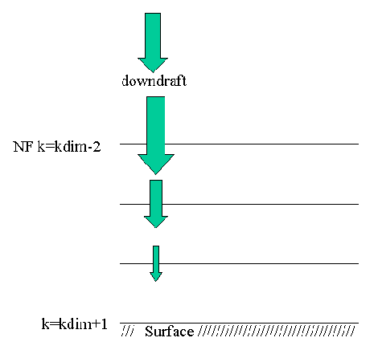
β = 0.0

This change of constant ß switches off the momentum transport from higher levels to the ground. This mechanism is important in cases were convection occurs in the region of an upper tropospheric jet stream.

But we still received complains about gusts, especially gusts without any convective activity (as seen by the users of our models). The reason is explained by the foregoing figure. Gusts are always combined with convective precipitation, until they reach half-level kdim-2. Below this level they are assumed to be constant down to the surface of the earth. But in the very dry August 2003, it often happened that precipitation evaporated between half-level kdim-2 and the surface. Therefore, no convective precipitation is predicted at the surface but the convective gust is still present. A modification prescribing a minimum convective precipitation rate (0.01 mm/h) at the surface is presently being tested in GME.
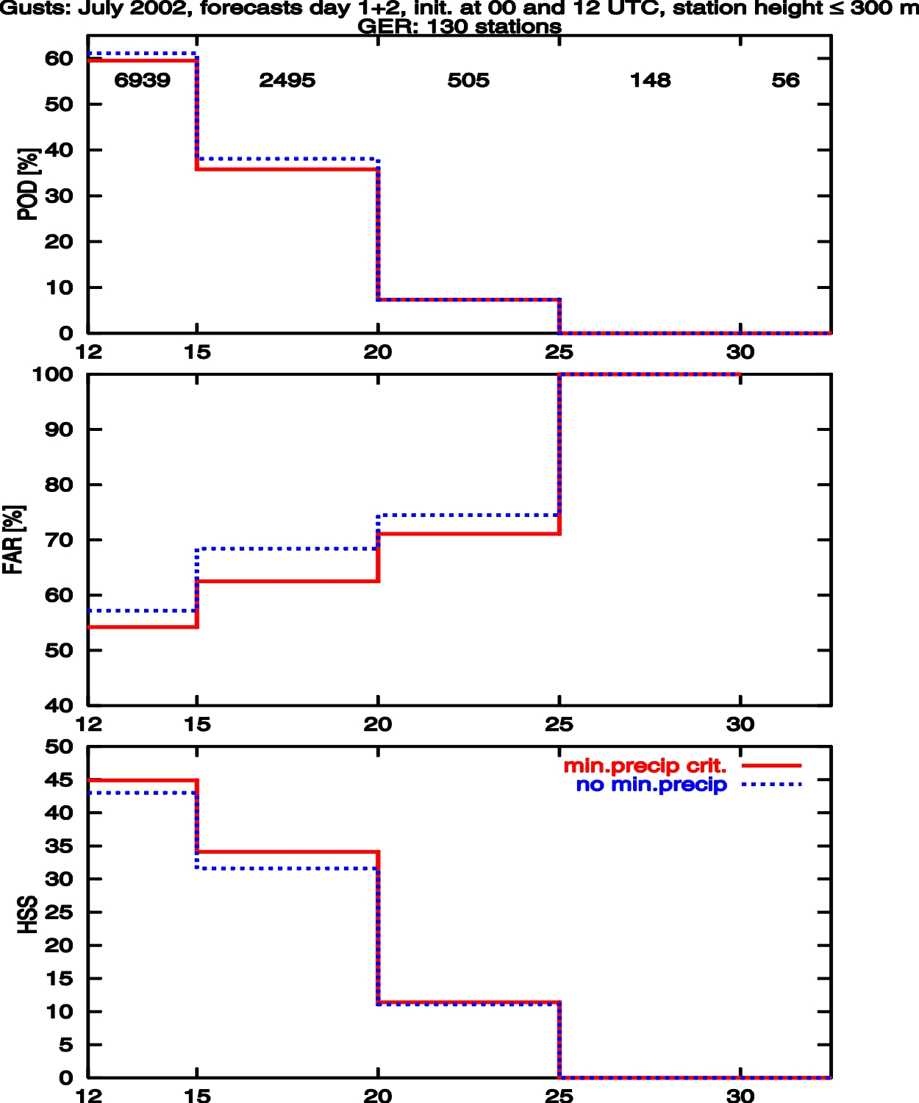
The verification results for Germany show a considerable decrease of the false alarm rate (FAR), the probability of detection (POD) is slightly reduced. The overall quality as shown by the Heidke Skill Score (HSS) shows a small improvement.

