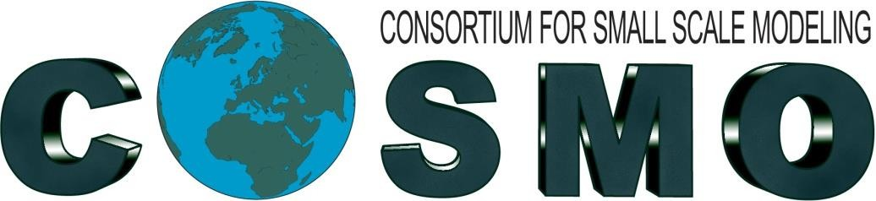

PP AWARE meeting @ICCARUS 2021, virtual,
16-17th March 2021

Agenda
- F. Gofa and A. Bundel – News and Status of PP-AWARE Tasks
- A.Bundel, A. Mazur, C. Marsigli – Report on Task 1.1 Overview of CW/HIW observational data sources characteristics
- D. Cattani – Advances in Verification of lightning probability with COSMO-2E and IFS
- G. Pante – Object based verification of radar-reflectivities on the convective scale (short overview)
- A.Bundel (for A. Murayev) – Results on Task 2.3 Extreme Value Theory (EVT) approach - Fitting precipitation object characteristics to different distributions
- D.I. Zakharchenko, D.V. Blinov – 15’ Simulations of Significant Tornadic events in Russia with a high-resolution COSMO-Ru (subtask 4.1)
- A. Mazur, J. Linkowska – 15’ Case study of bow echo/derecho on August 11th, 2017 - Flashrate verification/convective indices: assessment for increasing model resolution
- All – Discussion of PP-AWARE future, ideas for extension (HiWeather)
Presentations are available in http://www.cosmo-model.org/view/repository/wg5/meetings and http://www.cosmo-model.org/view/repository/wg4.

Minutes of the discussion
- F.Gofa presents the news and the status of the various project Tasks. After the endorsement of AWARE from the WMO-HiWeather project, PP-AWARE was presented during the IVMWorkshop in Nov 2020. With respect to the Tasks:
Task 1.1 is completed, with a pending final report, (A.Mazur, C, Marsigli, A.Bundel)
Task 1.2 analysis of methods to introduce obs uncertainty is under preparation (A.Bundel)
Task 2.1 is completed but a revised report will be submitted with applicability of recommended methods and suggestions for parameters to account for flash rate derived from forecast data. (A. Mazur and J.Linkowska)
Task 2.2 is completed and a paper/report was submitted in COMECAP 2021. (Boucouvala, Gofa)
Task 2.3 is completed and a written report/journal is expected. (A. Muravyev)
Task 3.1 is ongoing while a revised report will be submitted with the analysis on thermodynamical indices (A. Mazur and J.Linkowska)
Task 3.2 work is ongoing and will be presented during GM2021. Report to follow. (D.Cattani)
Task 3.3 work is ongoing and will be presented during GM2021. Report to follow. (A.Bundel)
Task 3.4 work was ceased after the preliminary work that was presented during May2020 meeting. Will be continued starting from April 2021.
Task 3.5 is completed and a report was submitted. (M.S.Tesini)
Task 3.6 SINFONY work is ongoing and the main advances are shared within this Task (G. Pante, M. Hoff)
Task 4.1 work is ongoing, report under preparation. (E.Tatarinovich, A. Bundel)
Task 4.2 is partially completed and task work is moved to PP-MILEPOSΤ. An intermediate report for PP AWARE is submitted.
Task 4.3 is completed and a final report was submitted. (M.S.Tesini)
Task 4.4 work is ongoing, participation of NMA still uncertain. Important to be clarified over the next weeks.
Action:
I. As no problems were reported, final deliverables for each subtask are anticipated prior to GM2021 for the preparation of the final report.
II. Information on any relevant publications or conference presentations, to be sent to the PLs as they need to be submitted to the final report.

- A. Bundel presented a summary of the overview of the report that is prepared to unite the contributions of Task 1.1.1, 1.1.2 and 1.1.3. This includes an analysis of observation types to describe HIW and the various sources to obtain them. After discussion on the deliverable, it was decided the report to include the presentation by observation source and include the observation types in it.
- D. Cattani presented briefly the progress of the work related to Verification of lightning probability of COSMO-2E and IFS (see slides).
- G. Pante presented a summary of the methodology he developed on the verification of NWC and NWP using object-based verification methods. This methodology is based on the calculation of pseudomembers (object with highest probability) resulted after having applied an extraction of objects based on the percentage of ensemble members that prognose each object, and then by applying a comparison with observed objects using MMI index (see slides and ICCARUS presentation).
- The presentation was cancelled due to lack of time, will be shown during GM2021.
- D. Zakharchenko presented work related to Task 4.1 with simulations of COSMO-Ru for the prediction of the risk areas with Significant Tornadic events in Russia using the Significant Tornado Parameter and Supercell Detection Index (check slides).
- A. Mazur presented the continuation of the work on Task 3.1 that is based on the evaluation of flash rate predictions as resulted from four different parameterizations and the subjective evaluation of thermodynamic indices prediction during a highly convective event (check slides).
- A discussion took place for the possibility of a new phase of PP-AWARE after September 2021 that the project is officially completed. Through the two years of the project some areas were not adequately analyzed and mainly concern the following areas/topics:
HIW phenomena: visibility range (fog), thunderstorms (w. lightning), intense precipitation, discrimination between severe and non-severe convection, extreme temperatures and winds.
Obs Types: application of non-conventional observations
Methodologies: Multivariate verification statistics (several gridpoints-leadtimes-variables in all possible combinations with respective το obs), further study on obs uncertainty with application to scores, Impact-based warnings issuing and evaluation
Models: application on convection permitting ENS, ICON-LAMs.
Especially for the spatial verification application on ensembles a discussion took place on a possibility of the future work to standardize object-based applications. Also, inspired by the publication of C.Marsigli et al. (2021): Observations for high-impact weather and their use in verification, a new filed of work could be initialized.
The short discussion resulted in the following possible direction of work after the end of PP-AWARE:
I. Stressing of observations role in HIW
- new obs types use in the evaluation of forecasted phenomena (severe convection, fog).
Obs Types:
  - Remote sensing derived non-conventional observations. Use of satellite products (e.g. cloud optical thickness, brightness temp, LWR, SWR) to evaluate characteristics of convection, NWC-SAF products for fog verification
  - Crowd-sourced data: third party and citizen met stations, smart phones, web & social media etc. usefulness for NWP predictions and evaluation.
- observation uncertainty and impact on scores
II. Verification scheme for convection permitting ensemble forecasts
- Object-based verifications: several methods and scores exist; the choice of the method depends also on the phenomenon to be verified. Still difficult to know how to use operationally in particular for ensembles.
- Proposal: focus on one (few) method and address how to use it for a probabilistic forecast (independently on the object-identification method and on the score)
Action: A summary of the motivation for a new project will be prepared and disseminated within WG5-WG4-WG7 and colleagues can add their ideas and tentative contributions. Based on the adoption of this proposal, it will be decided if a continuation of PP-AWARE (phase II) on HIW related work, or a separate new project proposal can be prepared and submitted by early summer to the SMC.

