For the numerical simulations, two versions of the ICON model were employed: the operational version v2.3.0 (control run) and the newer version v2.6.5.

Table 1. Model configurations used for specific test cases marked with Y; configurations used for specific cases but not presented in the detailed analysis marked with x; identified optimum configuration in bold.
Model Set-up | Oper/ Ctrl | v265 | v265EGr1 | v265EGr2 | v265EGr3 | v265ESh1 | v265  ESh2 | v265ESh3
version | 2.3.0 | 2.6.5 | 2.6.5 | 2.6.5 | 2.6.5 | 2.6.5 | 2.6.5 | 2.6.5
shallowconv_only | true | true | false | false | false | true | true | true
grayzone_deepconv | false | false | true | true | true | false | false | false
radiation | RRTM | RRTM | ecRad | ecRad | ecRad | ecRad | ecRad | ecRad
Laminar resistance | 1.0 | 1.0 | 1.0 | 10.0 | 20.0 | 1.0 | 10.0 | 20.0
Convection cases (heavy precipitation) | Y | Y | Y | Y | Y | Y | Y | Y
Convection cases (hail) | Y | - | - | - | - | - | Y | -
Winter cases (mixed precipitation) | Y | - | - | x | - | - | Y | -
Long-term evaluation | Y | - | - | x | - | - | Y | -

From the analysed cases with heavy precipitation in the convective season, the best results were obtained using the shallow convection parameterization, ecRad radiation scheme and klaminar resistance 10.
3. Numerical Simulations For The Convective Season
3.1. Heavy precipitation (31 August 2022 – 3 September 2022)

The heavy precipitation registered during this period especially in the South areas of Romania were thus determined both by synoptic scale factors (short wave through ensuring updrafts over the baroclinic area near the surface and the anticyclonic blocking pattern at the surface) and by local factors (forced updrafts induced by orography and low level jet stream leading to increased humidity in the boundary layer).
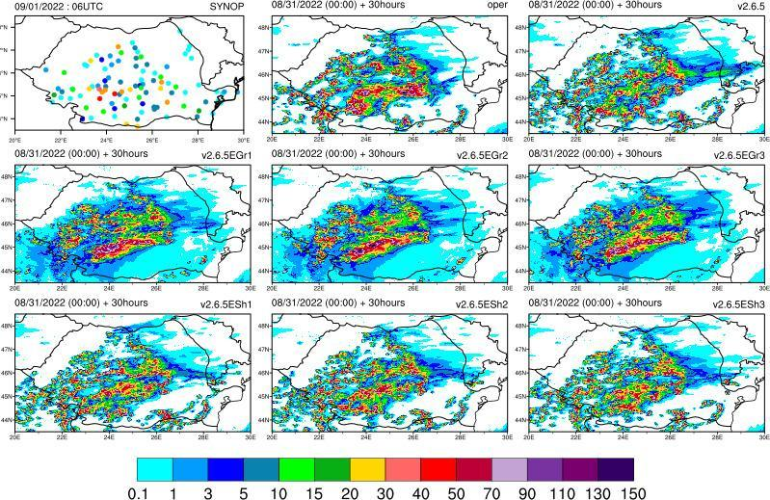
24 hours accumulated precipitation for 31.08.2022 06UTC – 1.09.2022 06UTC; left to right, top to bottom: observations, control run, v265, v265EGr1, v265EGr2, v265EGr3, v265ESh1, v265ESh2, v265ESh3. Model runs from 31.08.2022 00UTC (30 hours lead time).

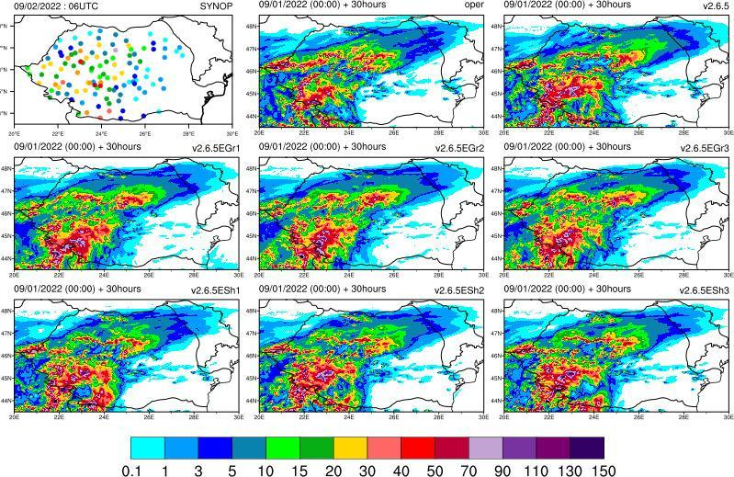
24 hours accumulated precipitation for 1.09.2022 06UTC – 2.09.2022 06UTC; left to right, top to bottom: observations, control run, v265, v265EGr1, v265EGr2, v265EGr3, v265ESh1, v265ESh2, v265ESh3. Model runs from 1.09.2022 00UTC (30 hours lead time).

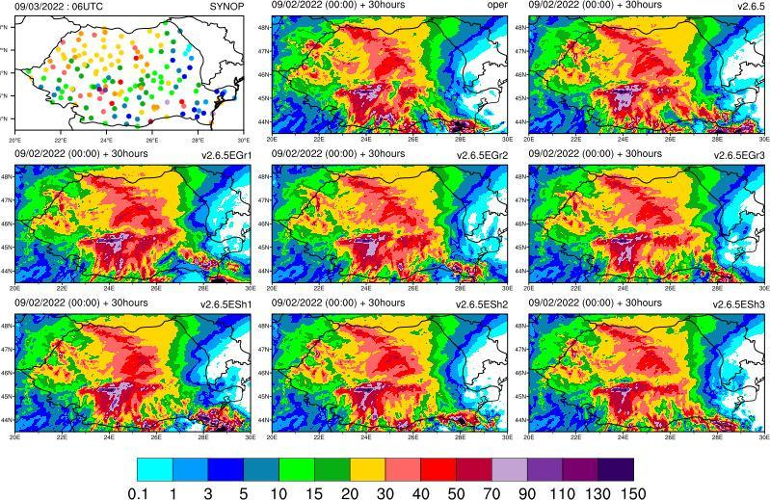
24 hours accumulated precipitation for 2.09.2022 06UTC – 3.09.2022 06UTC; left to right, top to bottom: observations, control run, v265, v265EGr1, v265EGr2, v265EGr3, v265ESh1, v265ESh2, v265ESh3. Model runs from 2.09.2022 00UTC (30 hours lead time).

Statistical scores were also computed for the interval 31.08.2022 03UTC – 6.09.2022 06UTC, for all configurations, for 3 hour accumulated precipitation, total cloud cover and surface parameters.

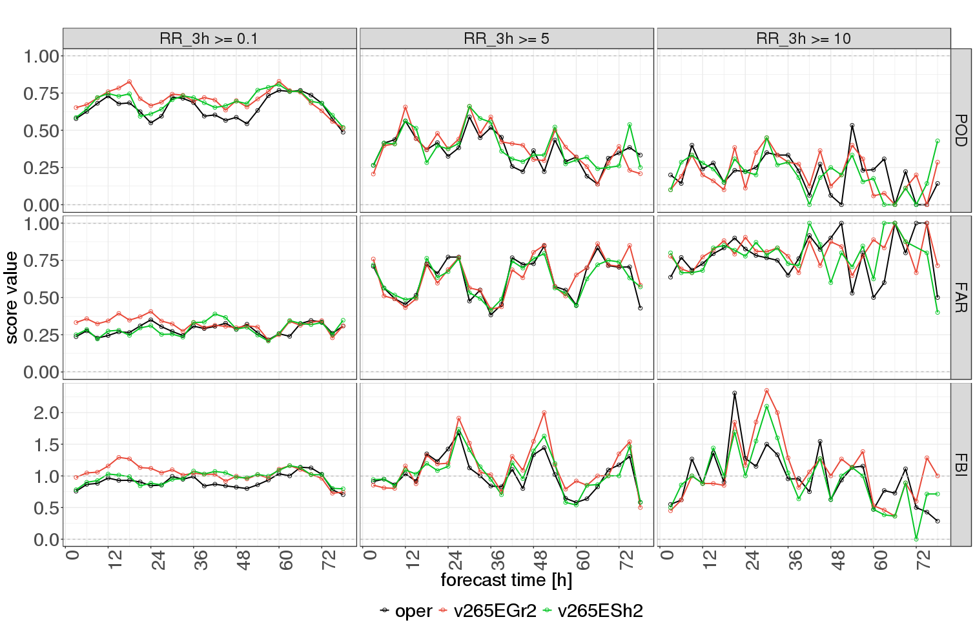
POD, FAR and FBI (top to bottom) for RR_3h >= 0.1mm/3h, RR_3h >= 5mm/3h and RR_3h >= 10mm/3h (left to right); results from oper/control (black), v265EGr2 (red) and v265ESh2 (green).

