On 17 November 2022 there was a low-level jet over north-western Switzlernad with gusts reaching 40 knots in the plain. Figure 1 shows that COSMO forecasted widespread gusts of around 40 knots in the western part of the Swiss Plateau and over the Jura mountains. ICON in comparison forecasted more localized peaks of around 40 knots. When comparing to the measurements in Figure 2, ICON was overall more accurate, while COSMO overestimated the gusts in the plain. However, ICON underestimated the gusts reaching 40 knots over the Ajoie (north-western part of Switzerland that kind of goes into France).
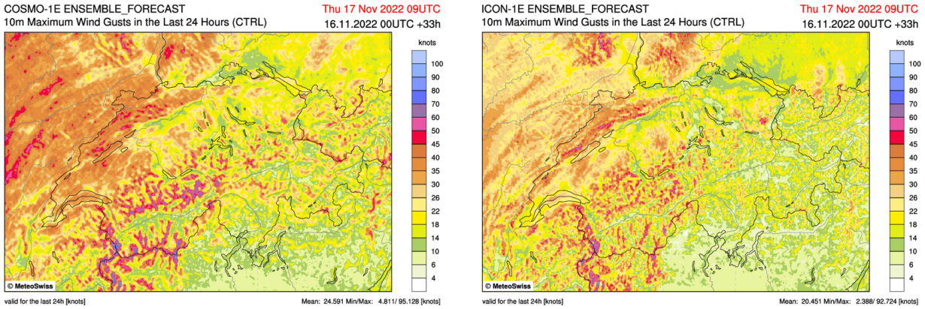
Figure 1: maximum wind gusts between 16 November at 09 UTC and 17 November at 09 UTC from COSMO-1E (left) and ICON-1E (right), lead-time 33 h.
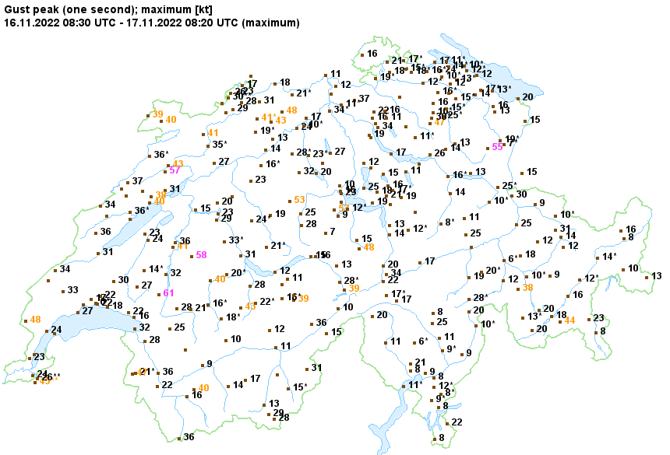
Figure 2: maximum gust measurements (in knots) between 16 November at 08:30 UTC and 17 November at 08:20 UTC from SwissMetNet stations.
For a case of non –severe weather, Figure 3 shows the forecast of low level clouds on 14 November 2022 at 12 UTC. ICON provided a much better forecast of low-level clouds over the Swiss Plateau than COSMO, which basically did not forecast it or dissipated the morning stratus too fast.
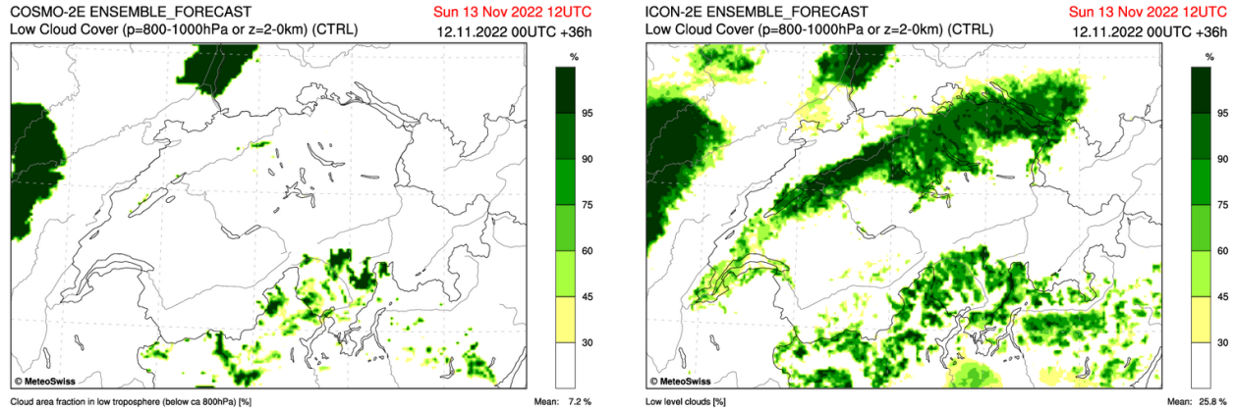
Figure 3: forecast of low-level cloud cover from COSMO-2E (left) and ICON-2E (right) on 13 November 2022 at 12 UTC (36 h lead-time)

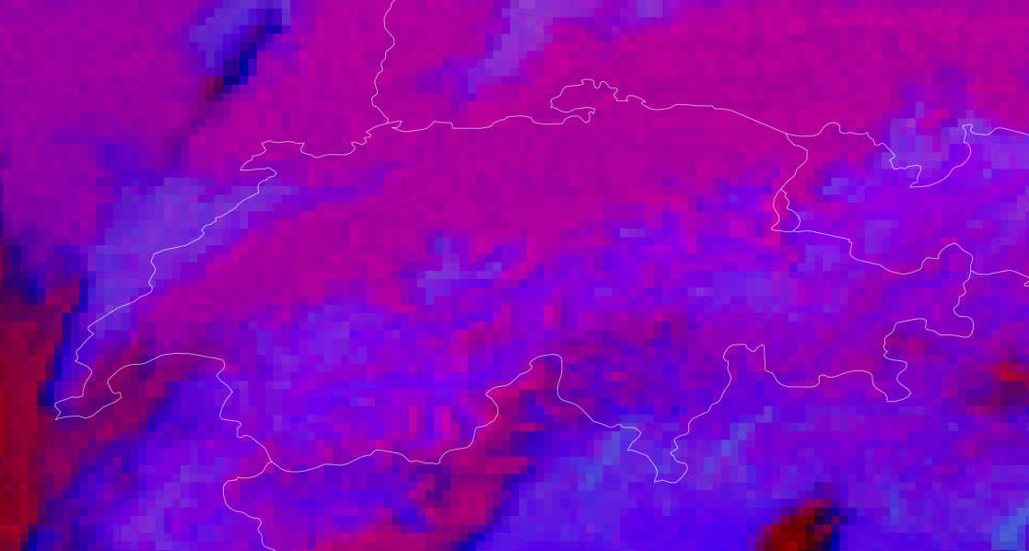
Figure 4 : satellite measurement over Switzerland on 13 November 2022 at 12 UTC. Source: Low Clouds RGB from MeteoSat Second Generation.
Figure
- Can you provide cases of ICON-LAM failure, if possible, along with a brief description of the actual synoptic situation?
12 January 2023 is a good example of overestimation of sunshine duration with ICON. The synoptic situation was dominated by a low-pressure system over the UK with a warm front passing over Switzerland. This lead to widespread clouds over the northern side of the Alps and more sun in the southern side.
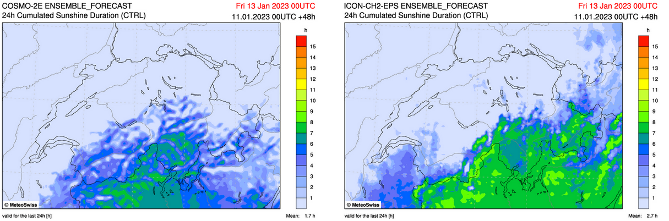
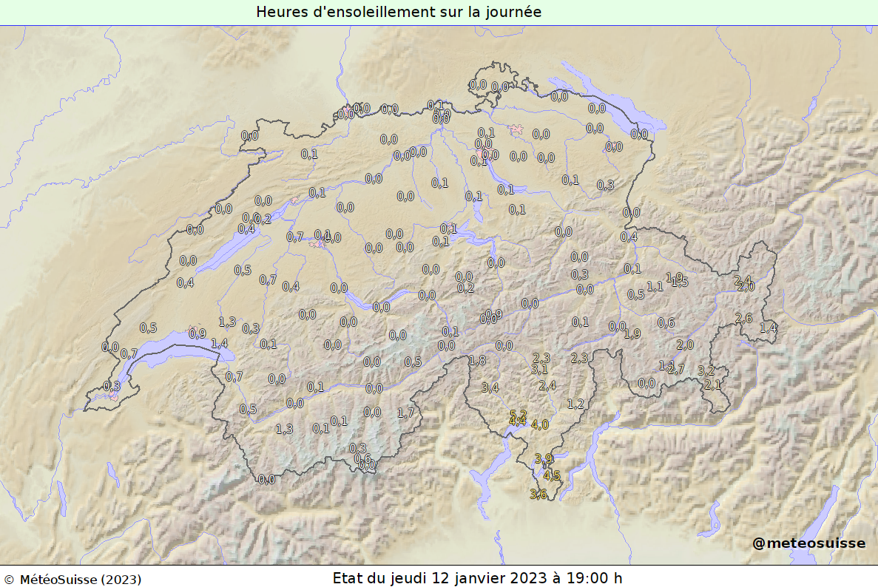
Figure 5: sunshine duration on 12 January 2023 from COSMO-2E (top left), ICON-2E (top right) and measurements (bottom).

