Case study - Flood over Marche region
On 15th September 2022 the Marche region was characterised by very intense and persistent rainfall, associated with organised thunderstorm systems originated in the central-northern mountainous and hilly areas of the region and later extended to the coastal area, which caused widespread criticality in the basins.

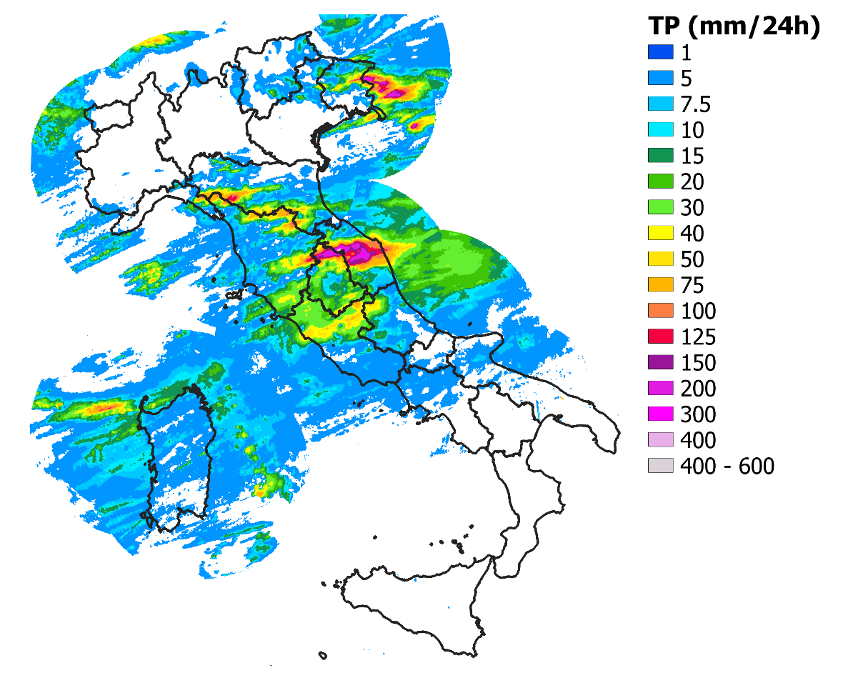
The central Italian regions were affected by westerly flows driven by a deep depression over Scandinavia, a secondary low over the Iberian Peninsula and high pressure over North Africa and the eastern Mediterranean. This situation channelled colder air of Arctic origin present at higher latitudes, which entered the central-northern Tyrrhenian regions via the Rhone, and, at the same time, warmer and more humid air from North Africa towards the central-southern Tyrrhenian regions. The acceleration of the strong winds at high altitudes (jet stream) and the Apennine barrage favoured the lifting of the warm and humid air present in the lower layers of the atmosphere, causing it to condense, which then caused showers and thunderstorms. The high lapse-rate and a significant wind shear, as well as very high CAPE, resulted in well-organised convective systems that caused cumulated rainfall exceeding 400 mm.
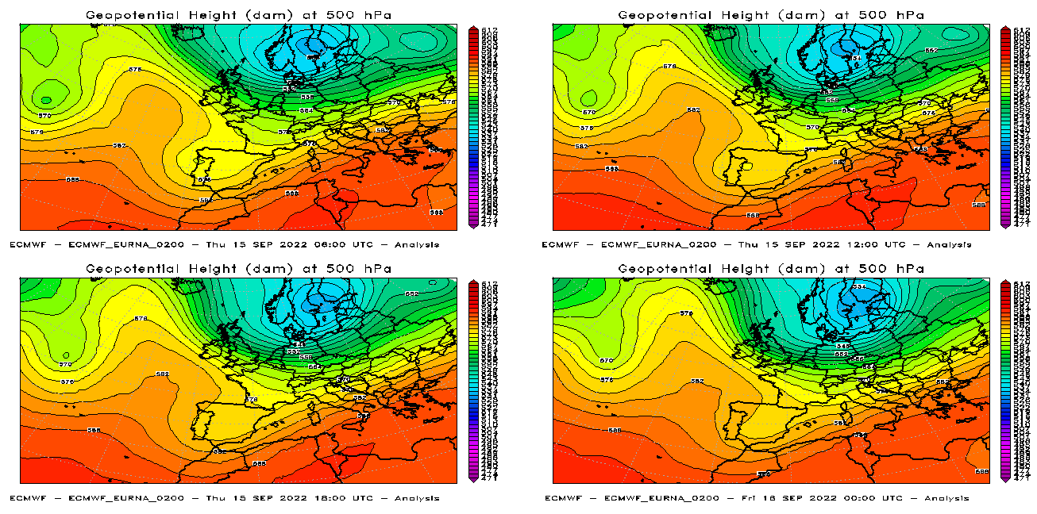
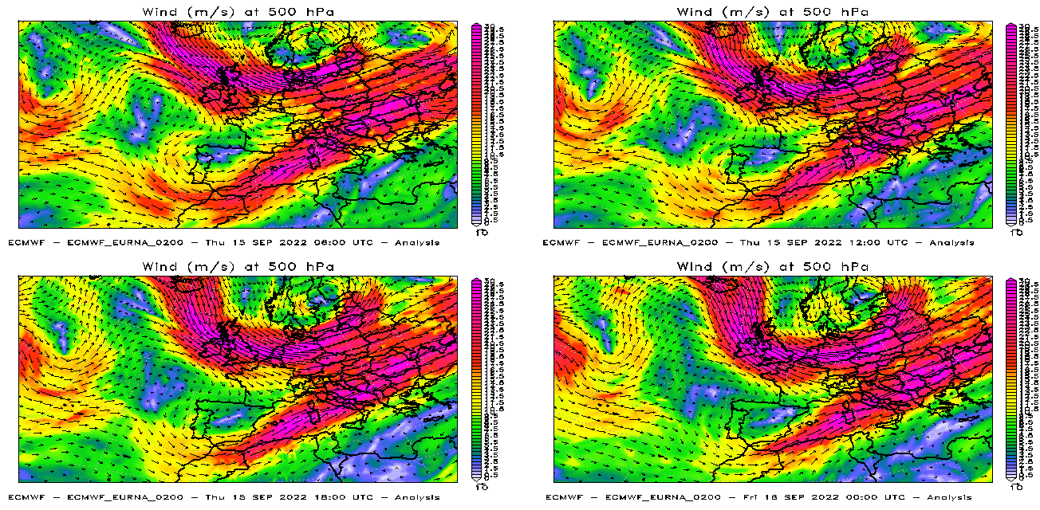
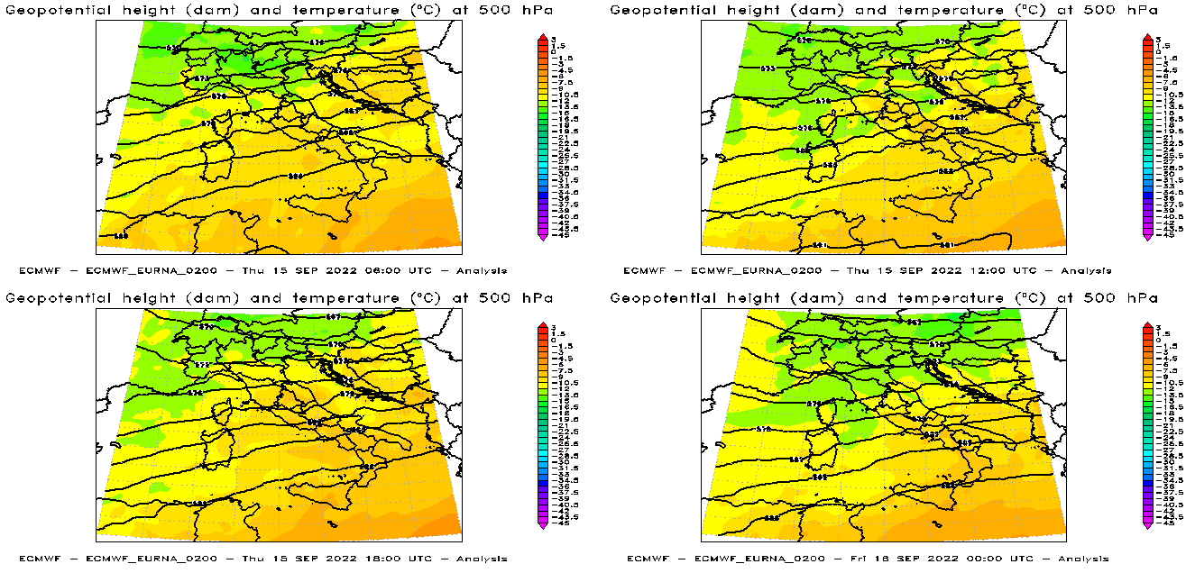
The event was not correctly predicted by the models. A qualitative evaluation is conducted through the eyeball technique, which consists of comparing the 24-hour cumulative precipitation on 15 September 2022 estimated by radar + rain gauges with the precipitation predicted by the 00UTC runs of 15/09/2022 of the models IFS, COSMO-2I and ICON-IT. No model was able to predict the intensity of the observed precipitation, but COSMO-2I identified the areas of greatest precipitation impact quite correctly: intense convective phenomena have been forecasted over the Tuscan-Emilian Apennines, eastern Friuli and between Umbria and Marche. No significant phenomena in terms of precipitation were forecasted by ICON-IT, whereas IFS predicted the most significant phenomena between Lazio and Campania.

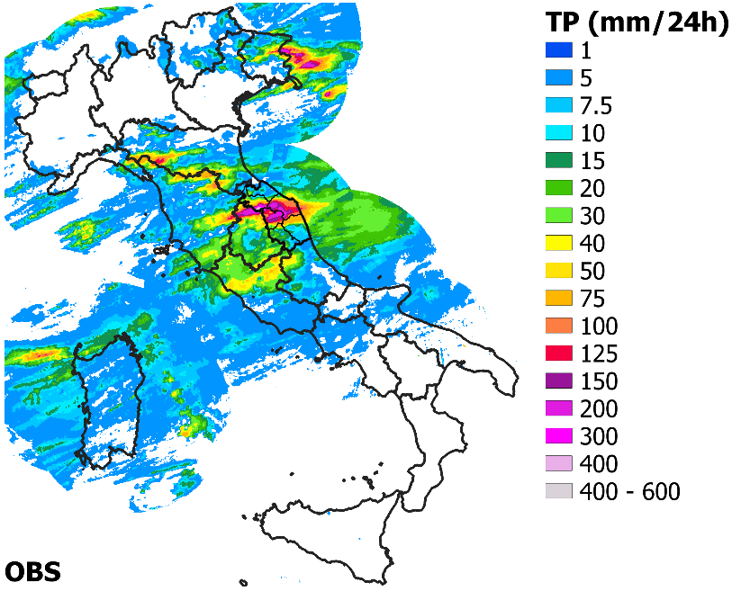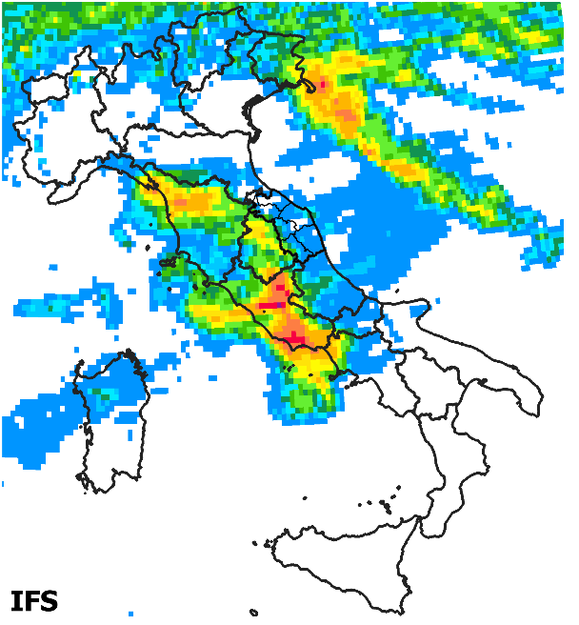
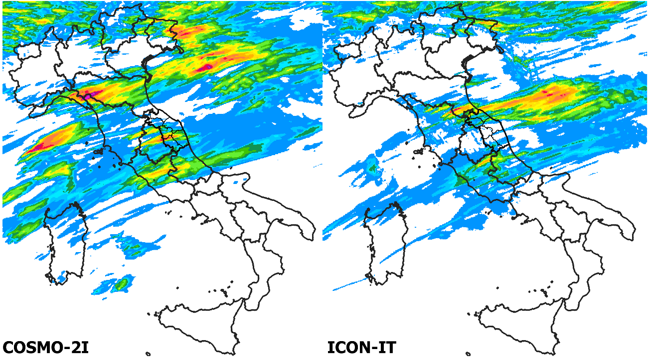

We also show the patterns predicted by the model run started the 14th September at 00UTC: with the exception of IFS, which seems to be more similar to observation, no significant phenomena are expected in the Marche region. The IFS forecast is degraded as it approaches the event.

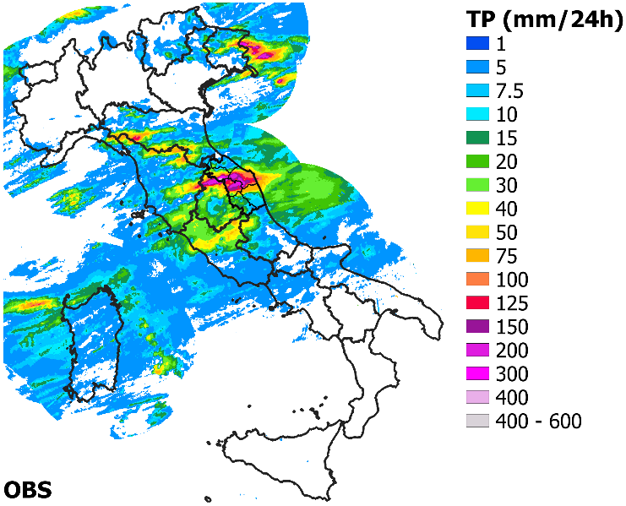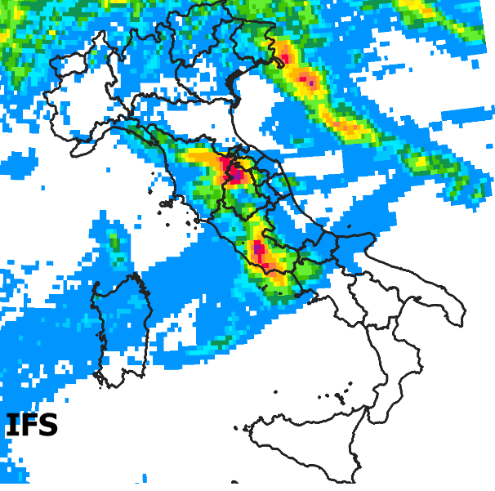
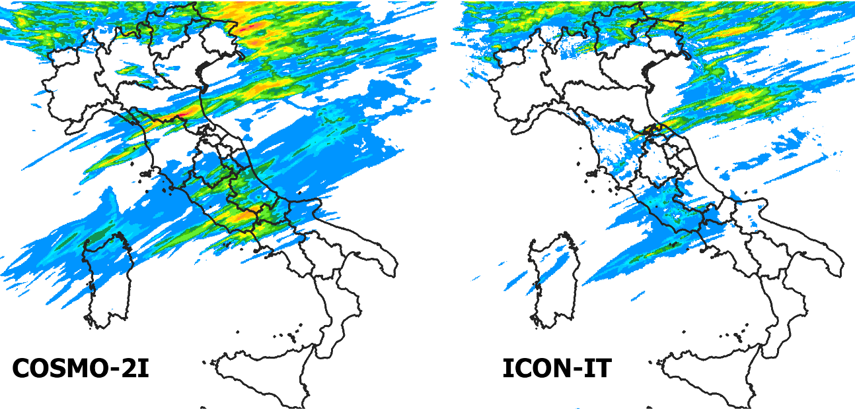
The QPFs provided by the models over the region's warning areas were then calculated and compared with those observed. The 24-hour cumulative average precipitation is represented by colour, while the 24-hour maximum value is represented by the number. As shown by the eye-ball check, no model was able to predict the intensity and the pattern of the observed phenomena. In particular, IFS and ICON-IT provided values that were an order of magnitude lower than the observed ones, while COSMO-2I was the only one to provide maximum values above 100 mm/24h, although still significantly lower than the observations.

