**Tornado hazard prediction with COSMO-Ru Parameters and indices**

**Denis Zakharchenko & Denis Blinov**

Recent research [Chernokulsky et.al, 2020] showed that on average Russia experiences from 100 to 150 tornadoes per year, although during some years this number can rise up to 350 events. Although the majority of these tornadoes are considered non-significant, about 10 percent of twisters can reach F-2 [Fujita, 1971] (or EF-2 [McDonald, et.al, 2004]) rated intensity and higher, causing serious damage and human deaths and injuries.

With very few exceptions, these significant tornadoes are associated with deep persistently rotating updrafts, found within supercells [Doswell & Burgess, 1993] and mesoscale convective systems.

Current numerical weather prediction models accepted by RosHydroMet cannot resolve tornadic vortices in operative forecasts. Although, a number of indices and parameters based on simulated characteristics of deep convection systems can help to predict the risk of a significant tornado forming along with accompanying severe weather hazards.

The current operative configuration for the COSMO-Ru model allows to run simulations with 2.2 km horizontal grid spacing within a domain covering the European Part of Russia (EPR) and other eastern European countries (Figure 1). Simulations with this 2.2-km grid configuration are performed with the Latent Heat Nudging (LHN) application. Parametrization schemes for COSMO-Ru domains are listed in **Table 1.**

The model output data includes the parameters for severe weather hazard diagnosis and prediction, such as the Lightning Potential Index (LPI) [Yair et.al, 2010], Hailcast Parameters [Adams-Selin & Ziegler, 2016], Supercell Detection Index (SDI) [Wicker et.al, 2005] along with common convective instability indices (CAPE, CIN).

The Supercell Detection Index represents a useful tool for identifying rotating updrafts in simulated convective cells and systems. Though the formation of a significant tornado requires the existance of mesocyclonic updrafts, it is not a sufficient condition, and other tornadogenesis factors must be taken into account. It is noted by the authors, that a value of 0.003 1/s is considered a significant threshold for supercell storms. It is important to note, that the SDI has two variations. In this study we refer to SDI_2. In this index, the positive values represent counterclockwise rotation (meso-cyclonic) whilst the negative represent meso-anticyclonic clockwise rotation.

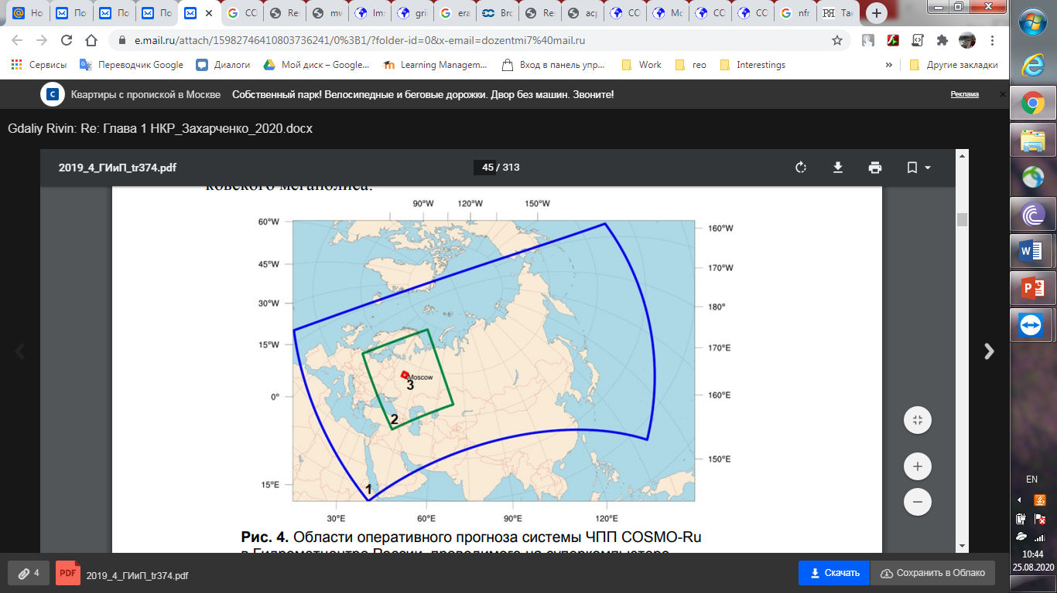

*Figure 1. Operative domains of the COSMO-Ru NWP system: 1- 6.6 km grid, 2- 2.2-km grid, 3- 1.1-km grid.*

**Table 1. Preferences for COSMO-Ru operative domains.**

|  |  |  |  |
| --- | --- | --- | --- |
| **Grid spacing** | **6.6 km** | **2.2 km** | **1.1 km** |
| **Vertical layers** | 40 | 50 | |
| **Mircophysics scheme** | Two-category ice scheme | Three-category ice scheme | |
| **Convection scheme** | Mass flux Tiedke scheme | Mass flux Tiedke scheme  (Shallow convection scheme) | |
| **Turbulence scheme** | 1-D TKE based diagnostic closure | | |
| **Time step [s]** | 50 | 20 | 5 |

Another parameter for estimating conditions favorable for significant tornado formation is the Significant Tornado Parameter (STP) [Thompson et.al, 2003]. It has not been implemented in the model, but can be calculated using the simulated instability indices and wind fields. This parameter requires the 0-1 km layer Storm-Relative helicity, which is calculated for right-mover (meso-cyclonic) tornadic supercells using the Bunkers storm motion method [Bunkers et.al, 2000]. It is specified that STP values higher than 1 represent a hazard for significant tornado occurrence. However, the disadvantage of this parameter as noted by the authors is in a high false alarm rate.

In previous studies with COSMO-Ru it has been noted, that the STP marks vast areas of favorable conditions for significant tornado formation, though often not within the range of simulated convective cells.

In respect to the statements above, the Significant Tornado Parameter (STP) and the Supercell Detection Index (SDI) simulated fields can be more informative if examined in complex.

The idea of this study is to analyze simulated COSMO-Ru fields during severe weather outbreaks with tornado activity in the European part of Russia in 2021.

According to the European Severe Weather Database [ESWD], there were 85 tornado records in Russia during the year, with 45 events identified as waterspouts, mostly observed on the coasts of the Black sea (Figure 2).

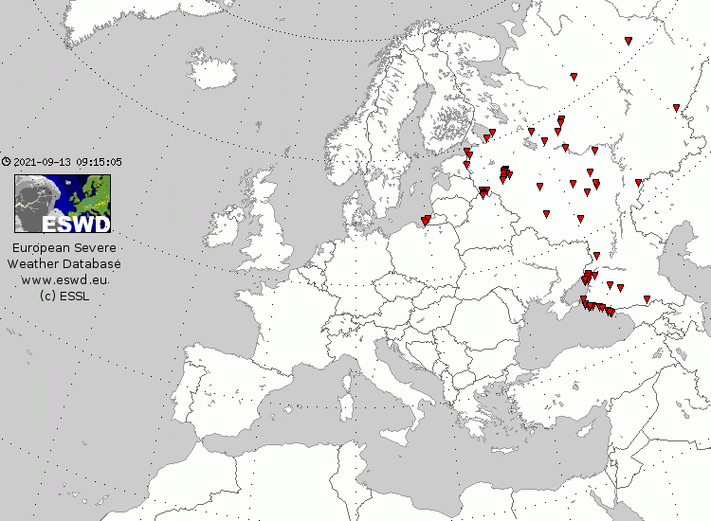

*Figure 2. Occurrence of Tornadoes in the European part of Russia in 2021.*

The most significant events took place on May 15 and August 2 the central European part of Russia. Our case studies are based on these two events.

On May 15, 2021 a group of supercells and mesoscale convective systems travelled across Moscow, Vladimir, Yaroslavl, Ivanovo, Kostroma and Vologda regions, resulting in a tornado outbreak and widespread straight-line wind damage. Analysis of satellite imagery of forest damage revealed at least 6 tornado tracks and a 360-km long squall damage path, indicating a possible derecho event in Vladimir and Kostroma regions (Figure 3). Several tornadoes, including one originated in a supercell in Yaroslavl region are rated F-2 and considered significant.

The initial time for the COSMO-Ru 2.2km simulation is 0:00 UTC May 15, 2021. At 08:00 UTC simulated convective cells already develop along the frontline, following a NNE trajectory and become recognizable in the simulated radar reflectivity field. In several cells the SDI already reveals signs of rotation, including a meso-cyclonic and meso-anticyclonic couple of updrafts in Yaroslavl region, which can be an indicator of a process known as “Supercell splitting”. At the moment, a stretched and narrow area of STP values exceeding the thresholds is present to the east of the simulated supercells with a maximum of 6 located in Ivanovo region (Figure 4).

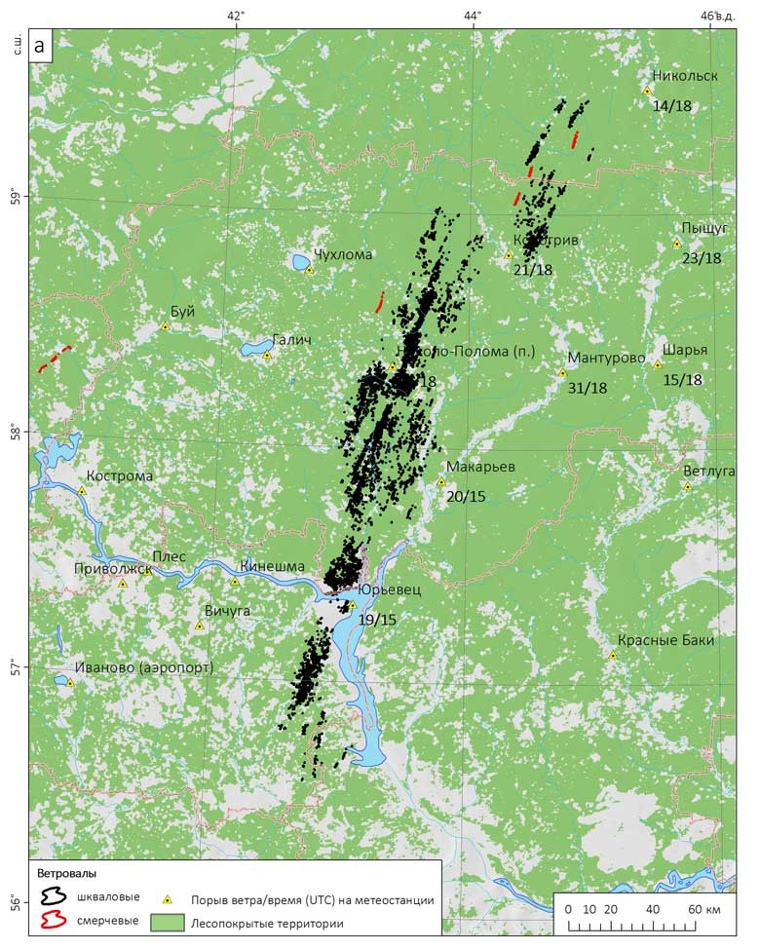

*Figure 3. Black hatching represents squall forest damage, red hatching – tornado-induced damage.*

At 13:00 UTC the area of increased STP values breaks into separate fragments, one of which migrates to Yaroslavl region. Approximately at this time an EF-2 tornado hit the town of Lyubim in the northeastern part of the region. In the simulation, a cell with high SDI values is located just at the northern border of the region, though not crossing the area with the highest STP values at the time (Figure 5).

Between 15:00 and 16:00 UTC a simulated mesoscale convective system with several rotating updrafts passes over the Kostroma region, matching the time the derecho event and tornadoes were observed. The STP field showed a maximum of 8 approximately at the location where tornado-induced forest damage were found. The maximum wind gust potential field revealed a vast area of high gust speed potential values, exceeding 38 m/s in some places (Figure 6).

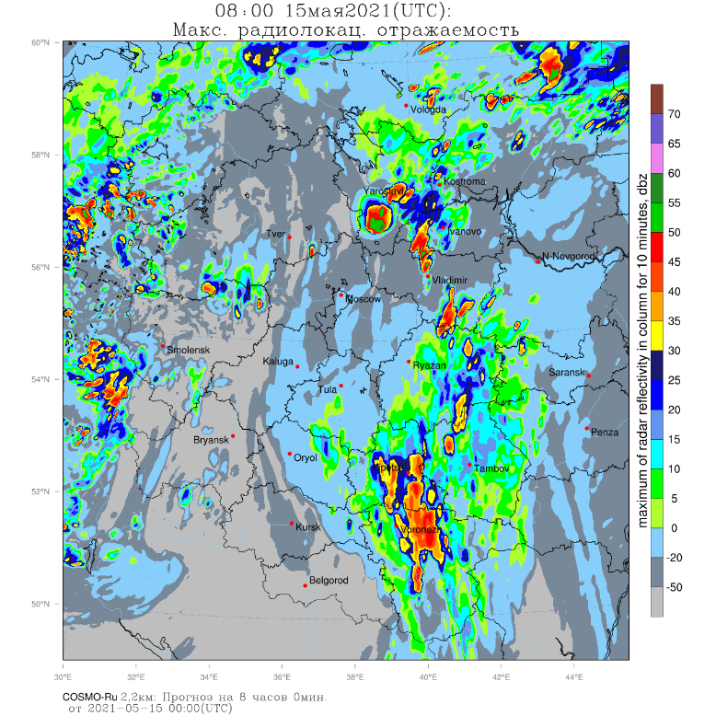 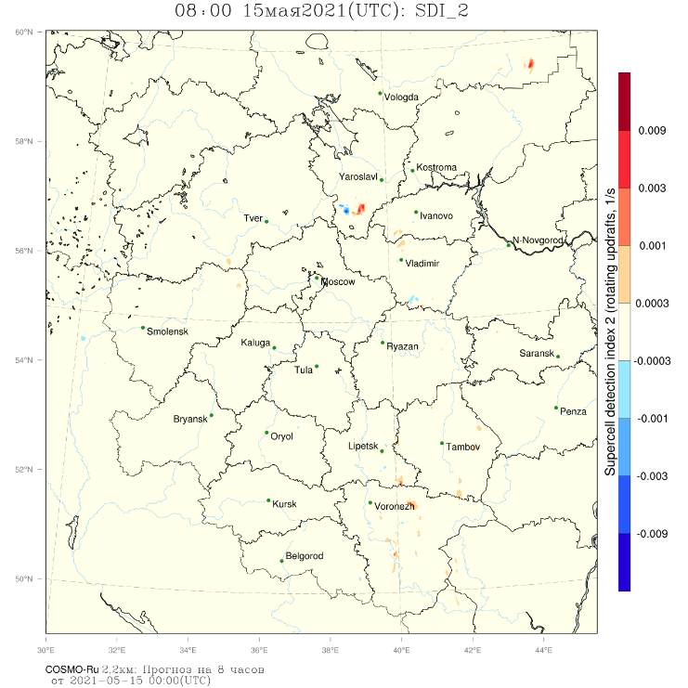

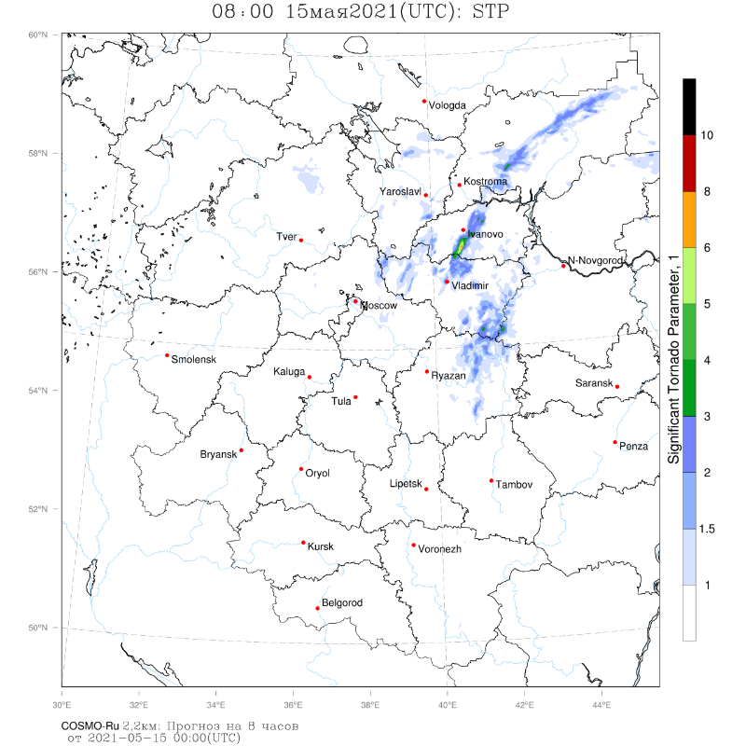

*Figure 4. Simulated 2.2-km grid COSMO-Ru fields at 08:00 UTC May 15, 2021:*

*Top left: Radar Reflectivity (dBz)*

*Top right: Supercell Detection Index 2 (SDI_2)*

*Bottom: Significant Tornado Parameter (STP)*

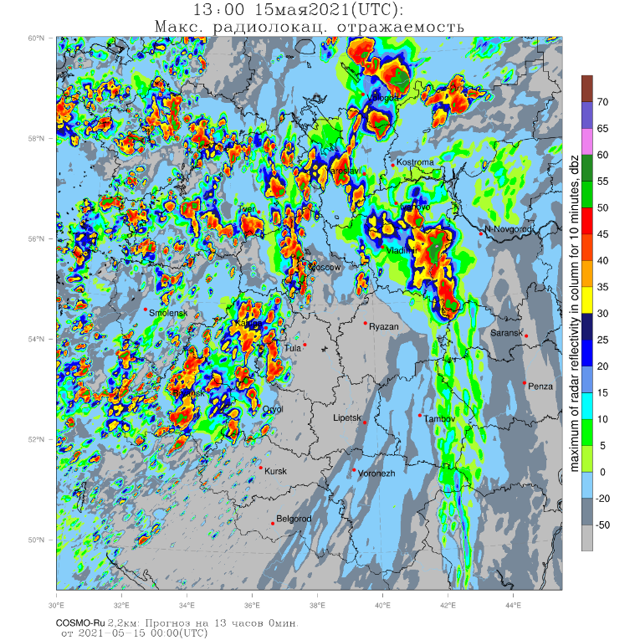 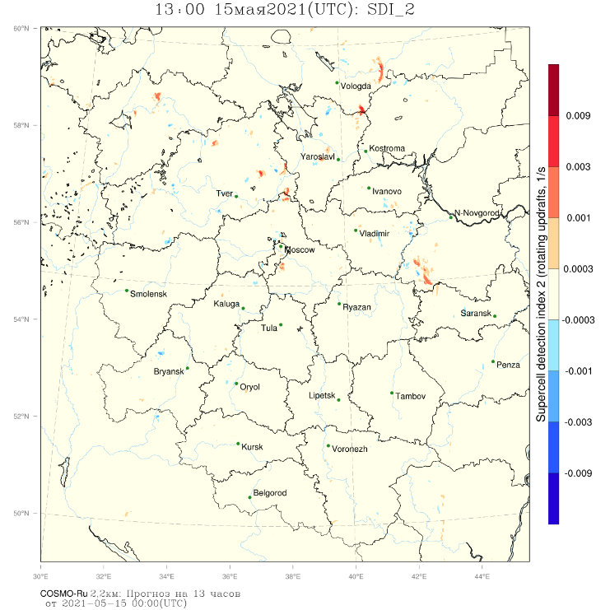

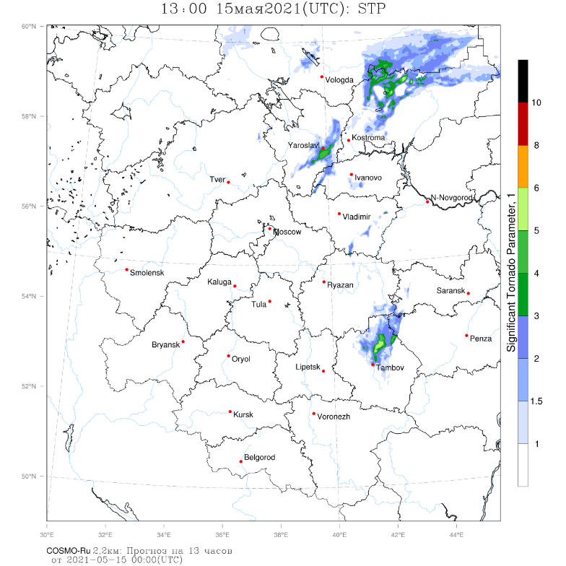

*Figure 5. As for Figure 4, 13:00 UTC*

In order to examine the structure of the simulated mesoscale convective system in detail, the 2.2-km grid model data was used to initialize a 1.1-km grid simulation within a small domain, surrounding the path of the derecho. As a result, the simulated radar reflectivity field revealed a “nearly textbook” picture of a bow echo system evolution with a detailed pattern-following area of severe wind gusts exceeding 40 m/s with a distinct gust front (Figure 7).

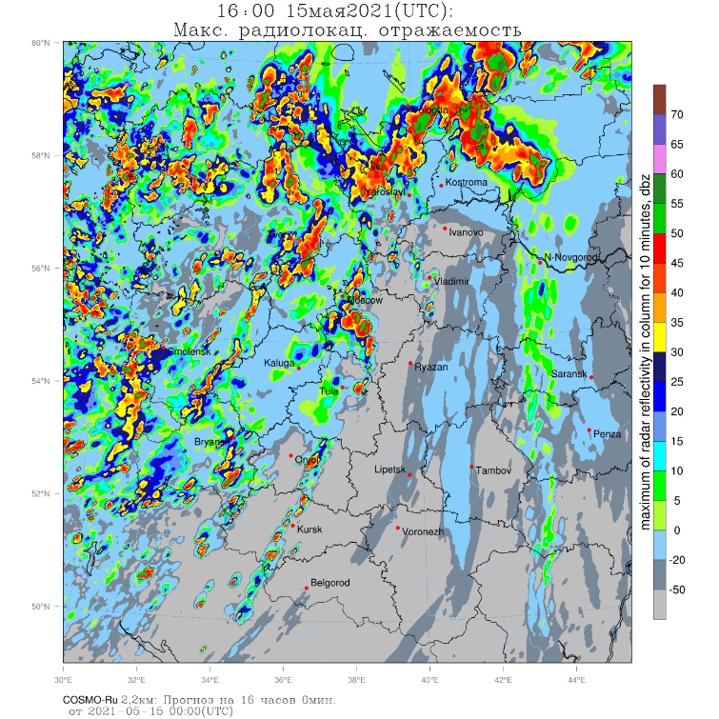 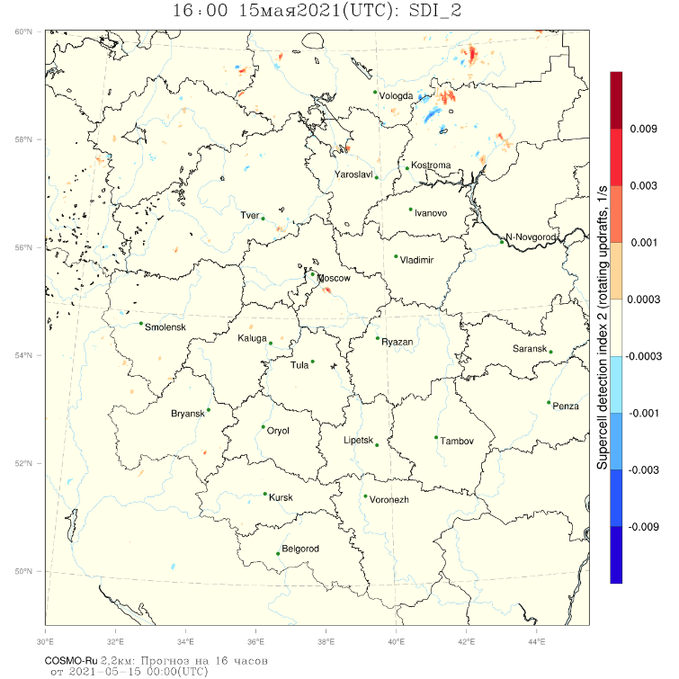

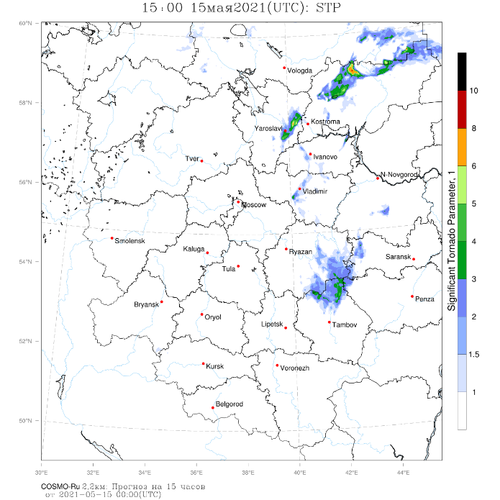 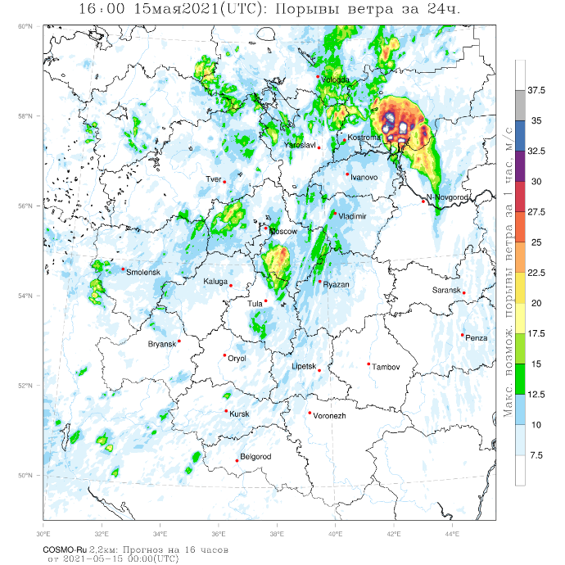

*Figure 6. As for Figure 4, 15:00 UTC*

*Bottom right: Maximum 10m AGL wind gust (m/s) for the last forecast hour.*

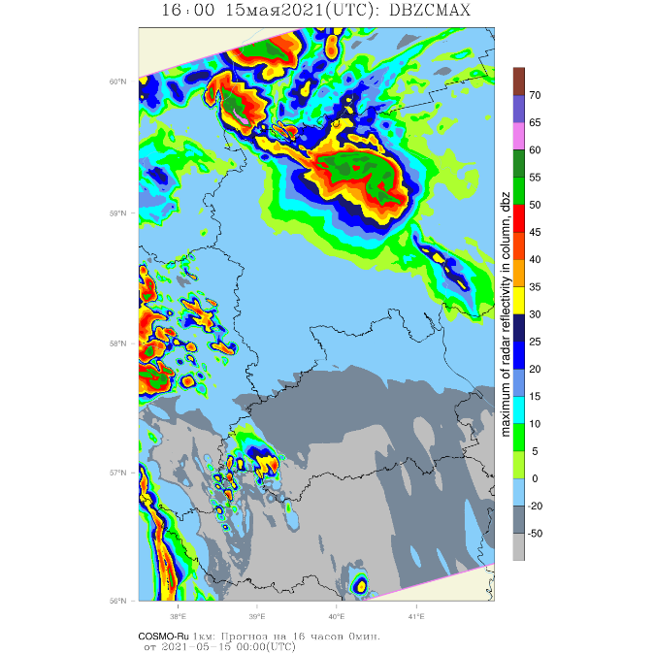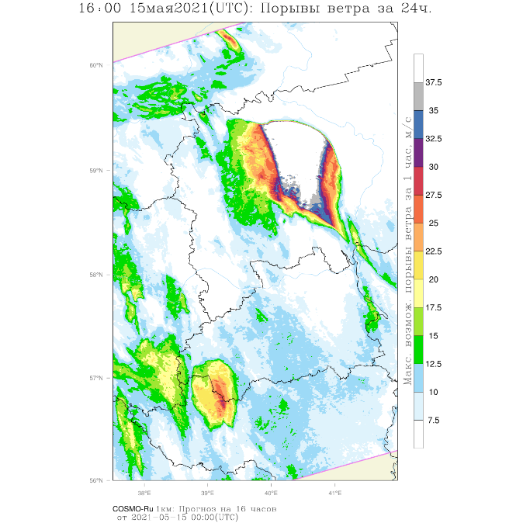

*Figure 7. Simulated 1.1-km grid COSMO-Ru fields at 15:00 UTC May 15,2021:*

*Left: Radar reflectivity*

*Right: Maximum 10m AGL wind gust (m/s) for the last forecast hour.*

The other case study event is the August 2 tornado outbreak in Tver and Pskov regions in western Russia. Satellite imagery analysis showed that at least 15 tornadoes touched down during the outbreak, including an F-3 rated tornado hitting Andreapol town in Tver region, killing 3 people and injuring 10 more [ESWD].

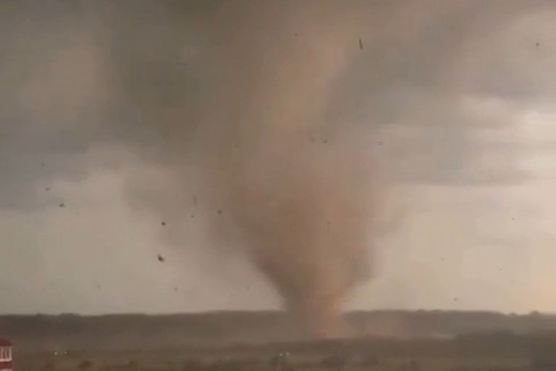 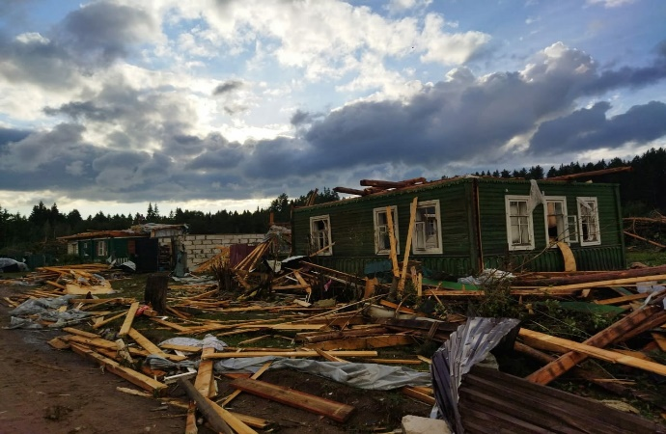

*Figure 8. Left: The Andreapol F-3 Tornado before hitting the town; Right – Tornado-induced damage in Andreapol town [https://vk.com/meteodnevnik]*

As in the previous case study, the model is initialized at 0:00 UTC. The 2.2-km grid simulations revealed the growth of a family of convective cells at 10:00 UTC over the western part of Russia. At 12:00 UTC numerous cells in Pskov and Tver region show signs of rotation and are marked with high SDI values. At the time, a widespread area of increased STP values is present over the surrounding regions with maximum values above 8 in Pskov region (Figure 9). According to ESWD, the tornadoes in Pskov region occurred between 12:00 and 13:00 UTC and reached F-1 intensity.

At 14:00 UTC the STP maximum values, accompanied by several simulated convective cells with high SDI values are observed in Tver region, matching the area where the number of tornadoes, including the Andreapol event occurred between 14:00 and 16:00 UTC (Figure 10).

As in case study 1, a 1.1-km resolution simulation within a smaller domain was initialized. As a result – more distinct radar reflectivity supercell shapes with higher values of SDI were acquired (Figures 11-12).

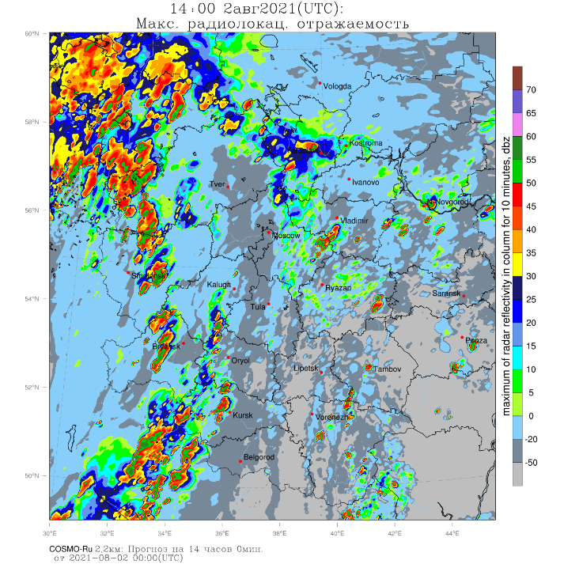 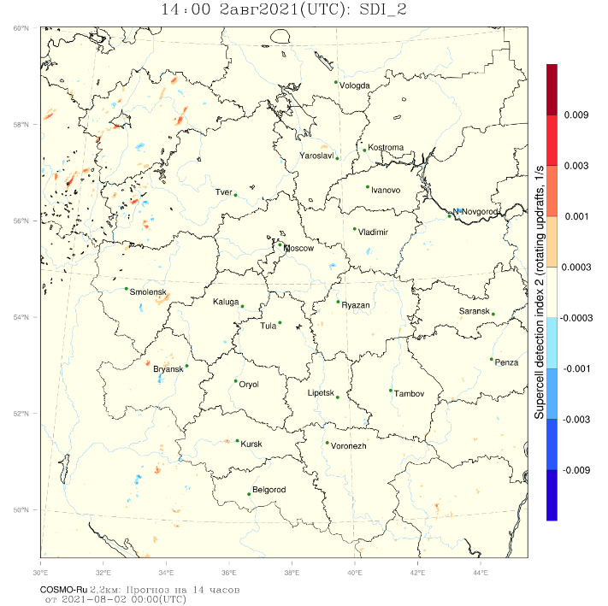

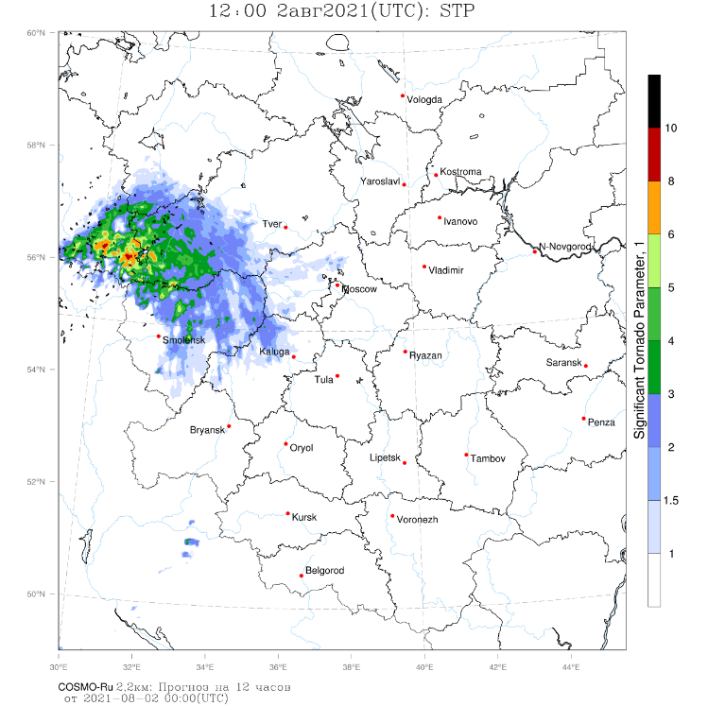

*Figure 9. Simulated 2.2-km grid COSMO-Ru fields at 12:00 UTC August 2, 2021:*

*Top left: Radar Reflectivity (dBz)*

*Top right: Supercell Detection Index 2 (SDI_2)*

*Bottom: Significant Tornado Parameter (STP)*

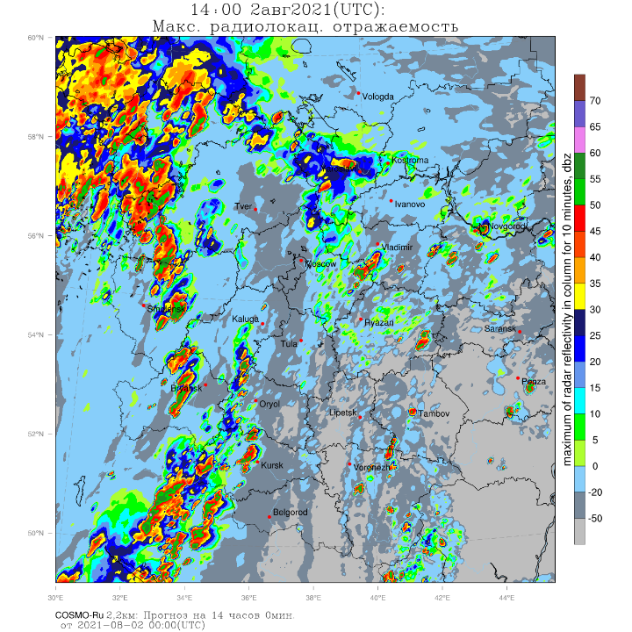 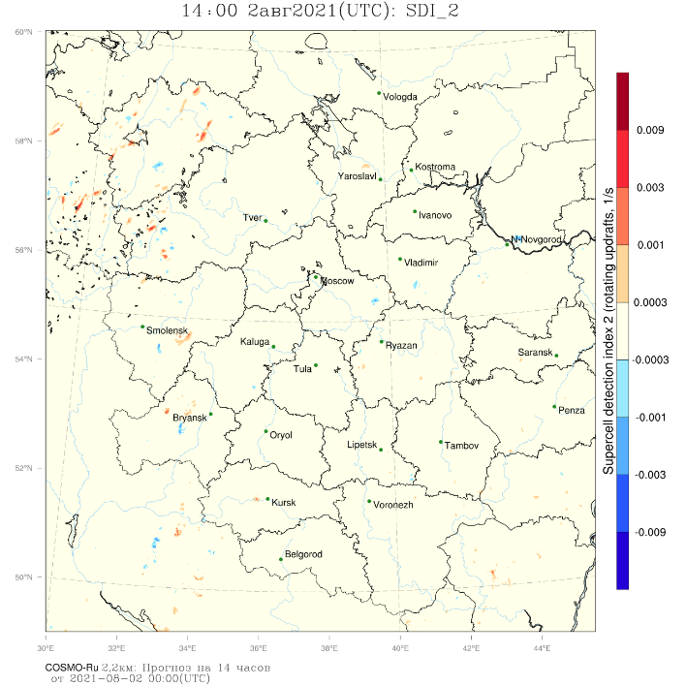

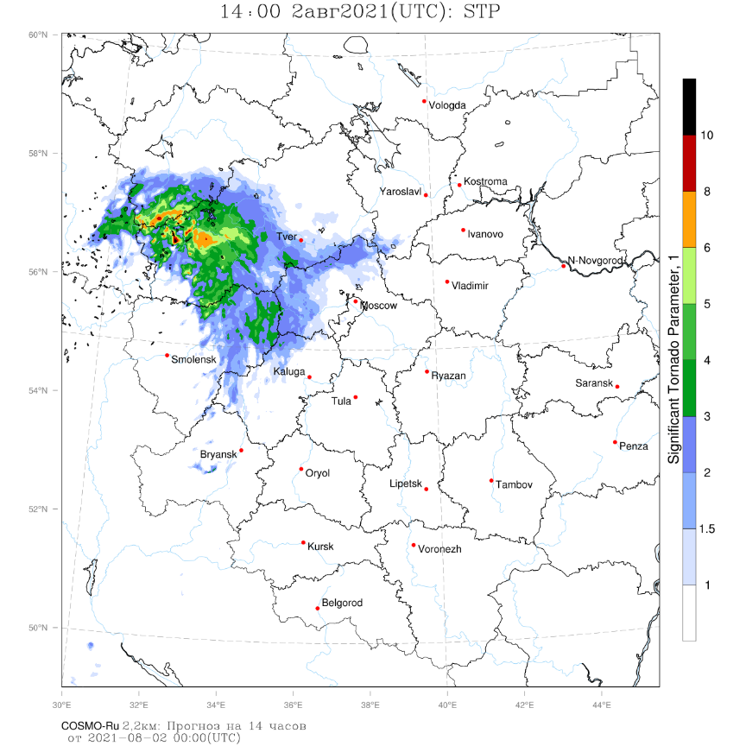

*Figure 10. As for Figure 9, 14:00 UTC*

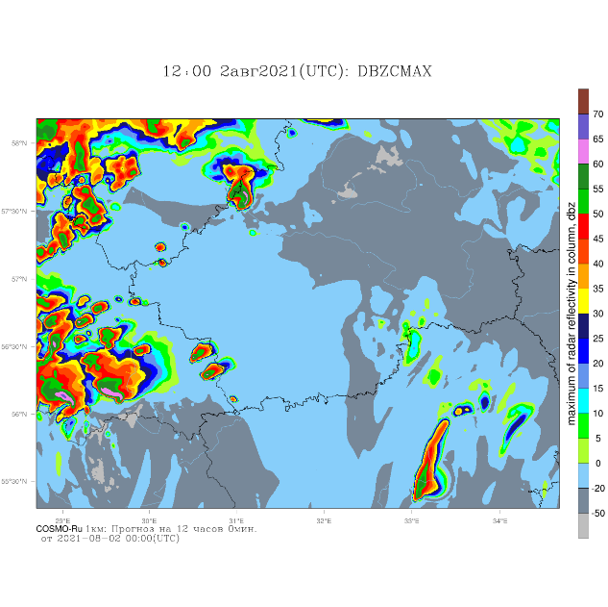 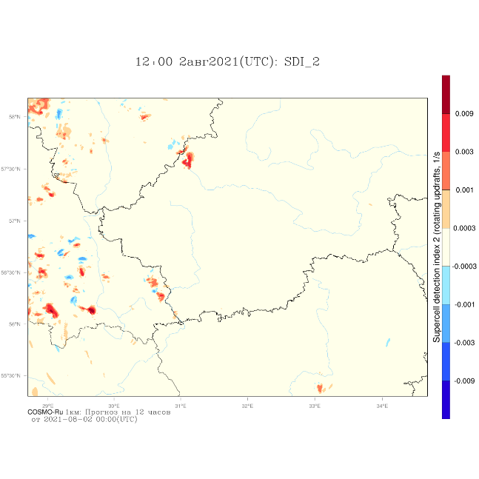

*Figure 11. Simulated 1.1-km grid COSMO-Ru fields at 12:00 UTC August 2, 2021:*

*Left: Radar Reflectivity; Right – Supercell Detection Index 2 (SDI_2)*

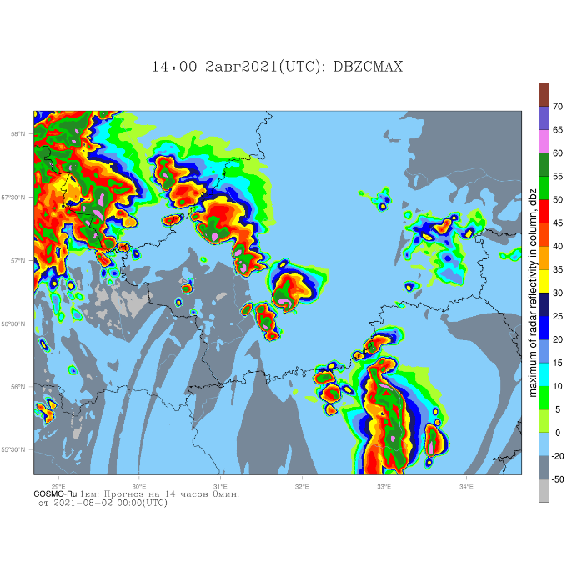 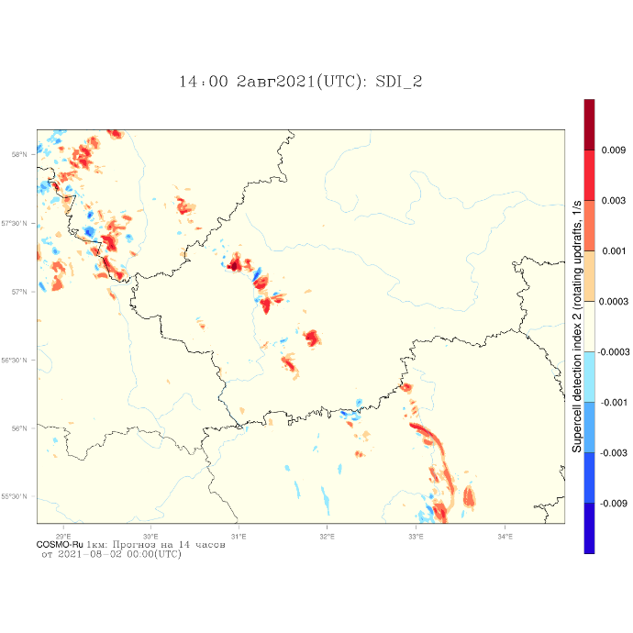

*Figure 12. As for Figure 10, 14:00 UTC.*

In conclusion: predicting tornado occurrence remains a challenge, considering today’s operational numerical weather prediction systems and the complex and unexplored nature of these intense phenomena. Nevertheless, convection-permitting models and grids can resolve both dynamical and empirical indicators of certain significant tornado events.

**The 2021 case study analysis showed that despite definite spatial and temporal errors when predicting actual significant tornado hazard locations, the joint use of COSMO-based SDI and STP indices can significantly clarify the risk area and exclude an amount of false alarms in certain regions.**

It is worth noting, that the 1.1-km-resolution simulations revealed, beyond any doubt, a more detailed picture of the simulated convective cells and systems. This detail may appear crucial for tornadic event diagnosis. Hence, a possibility of an operative 1-km grid COSMO-Ru setup for severe weather prediction is in need of consideration.

**References:**

1. Adams-Selin, R.D. and C.L. Ziegler, 2016: Forecasting hail using a one-dimensional hail growth model within WRF.Mon. Wea. Rev.,144, 4919–4939.
2. Bunkers, M. J., Klimowski, B. A., Zeitler, J. W., Thompson R. L., Weisman, M. L., 2000: Predicting Supercell Motion Using a New Hodograph Technique. Weather and Forecasting, 15.
3. Chernokulsky, A., Kurgansky, M, Mokhov, I., Shikhov, A., Azhigov, I., Selezneva, E., Zakharchenko, D., Antonescu, B., Kuhne, T., 2020: Tornadoes in Northern Eurasia: From the Middle Age to the Information Era, Monthly Weather Reviews 148 (8): 3081-3110.
4. Doswell, C., Burgess, D., 1993: Tornadoes and Tornadic Storms: a Review of Conceptual Models. The Tornado: Its Structure, Dynamics, Prediction, and Hazards, Volume 79.
5. Fujita, T., 1971: Proposed characterization of tornadoes and hurricanes by area and intensity. University of Chicago SMRP Research Paper 91, 42.
6. McDonald, J. R., Mehta, K., C., 2004: A Recommendation for an Enhanced Fujita Scale. Texas Tech University, Lubbock, TX, USA.
7. Thompson, R. L., Edwards, R., Hart, J. A. Close proximity soundings within supercell Environments Obtained from the Rapid Update Cycle, 2003 // Weather and Forecasting, 2003, Vol. 18, P. 1243-1261.
8. Wicker, L., Kain, J., Weiss, S., and Bright, D. A Brief Description of the Supercell Detection Index (2005)
9. Y.Yair, B. Lynn, C. Price et al. Predicting the potential for lightning activity in Mediterranean storms based on the weather research and forecasting (WRF) model dynamic and microphysical ﬁelds // Journal of Geophysical Research, 2010, Vol. 115, article D04205
10. <https://eswd.eu/>
11. http://meteoweb.ru/2021/news/wn2021053100.php