1. Reliability vs. workload – meteorological input for hydrological models in enhanced spatio-temporal resolution (case study).

Summary
According to both meteorologists and hydrologists increased model resolution should result in better forecast (especially precipitation over complicated terrain). Still, this would also result in increase of computing time and costs. Thus, this topic is aim to answer the following question: how would enhanced resolution (and increased workload and costs) impact on a quality of forecasts? During the study selected results of QPF simulations were compared - over chosen region - with operational forecasts of IMWM version of COSMO. Since both forecasts domain have a different resolution (7 and 14 km, respectively) the goal of this comparison is to assess if it's possible to estimate an influence of enhanced resolution on quality of precipitation forecast. If any, we should also try to establish how to avoid problems with increased workload.

Methods
To compare the results of use of enhanced resolution we selected main periods of QPF experiment scheduled for Polish domain, namely May 4th, June 10th and August 9th, all 2005. We established results of precipitation forecasts from 07 and 14km versions of COSMO (further referred as LM-07 and LM-14) for chosen terms over Poland. Results of total precipitation (TOT_PREC) were also divided into convective and grid-scale types of precipitation (RAIN_CON and RAIN_GSP, respectively). For all cases mean bias, mean absolute bias and RMSE were calculated.

Results
In following pictures the results of comparison are shown. In the forecast picture, left chart(s) below always shows results of LM-07 while right – LM-14.
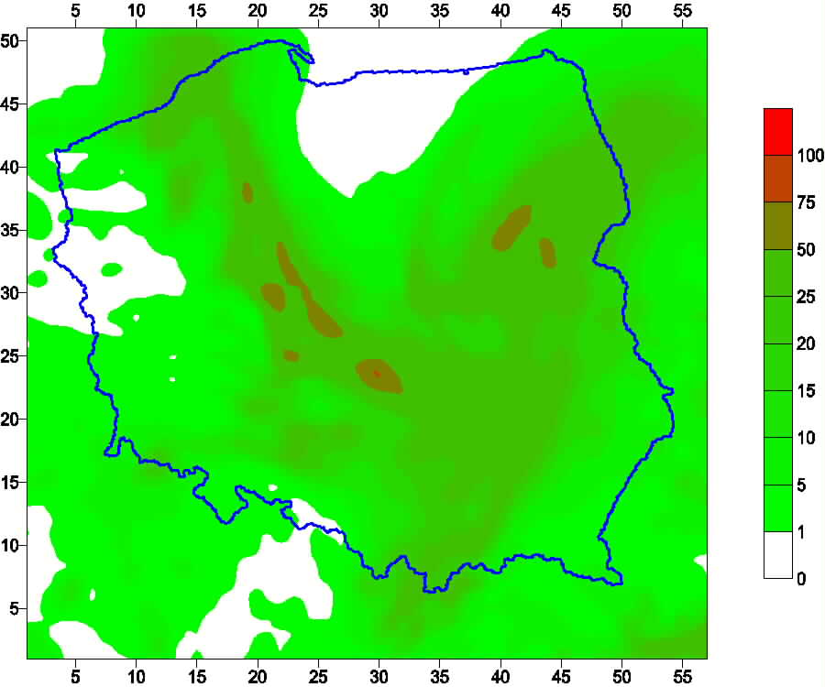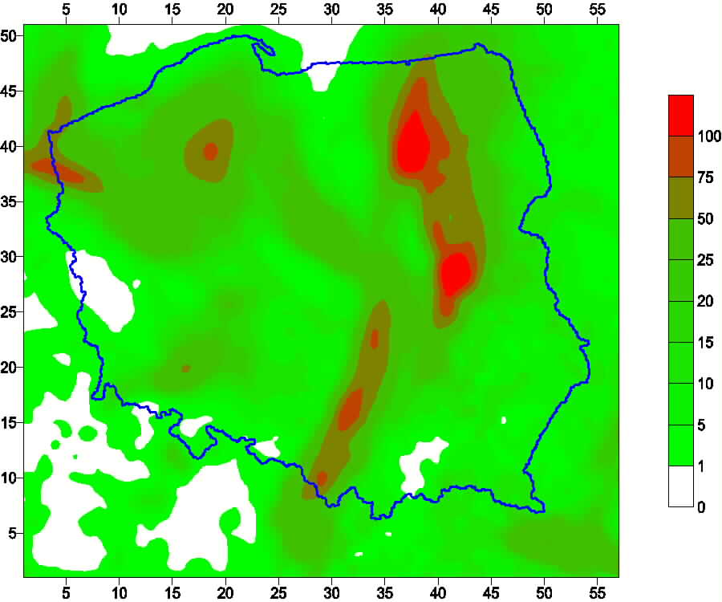
Fig. 1. Total precipitation (mm) forecast, May 4th, first day of forecast
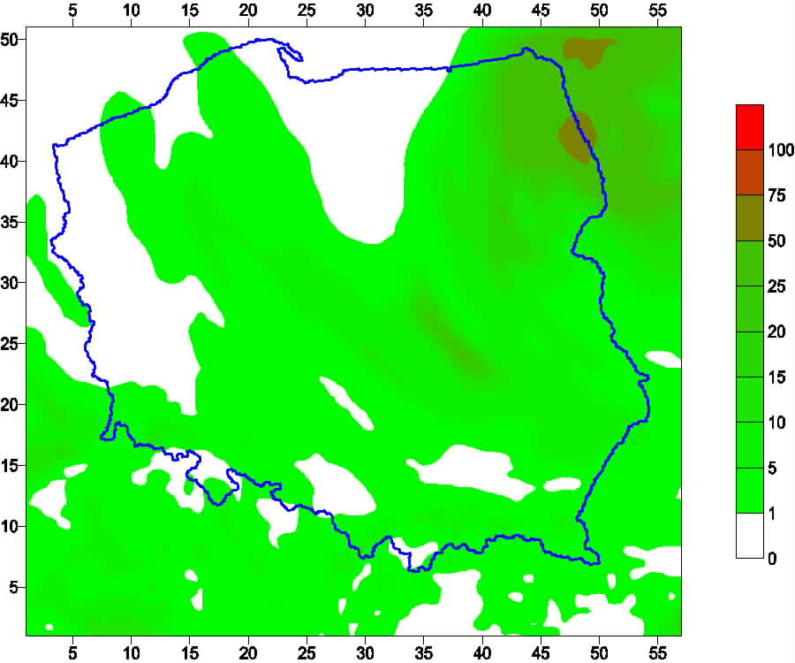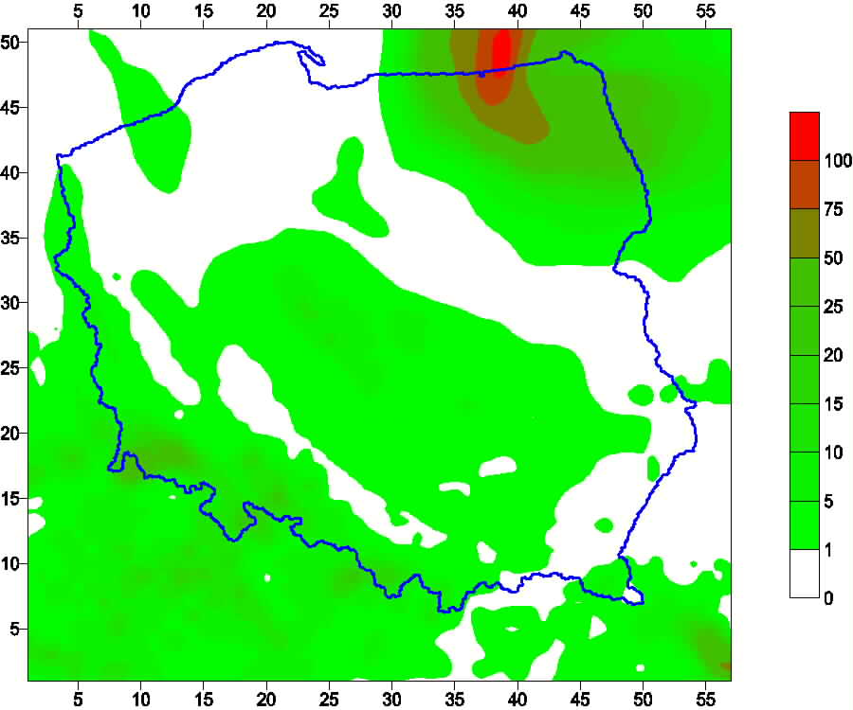
Fig. 2. Total precipitation (mm) forecast, May 4th, second day of forecast
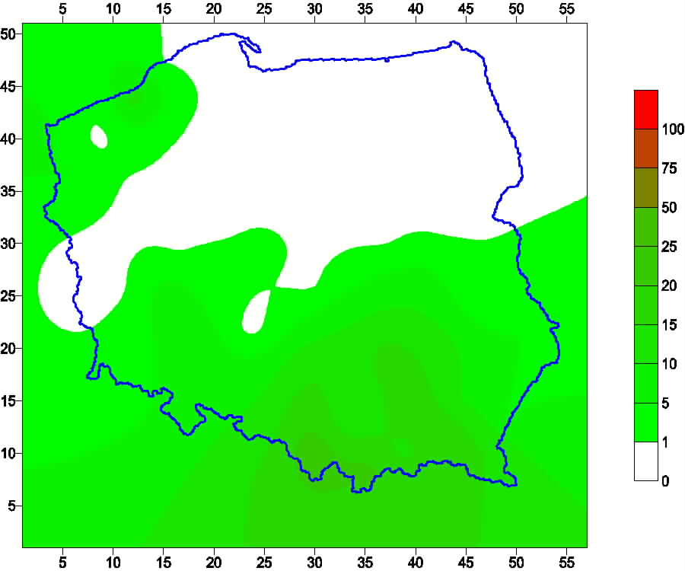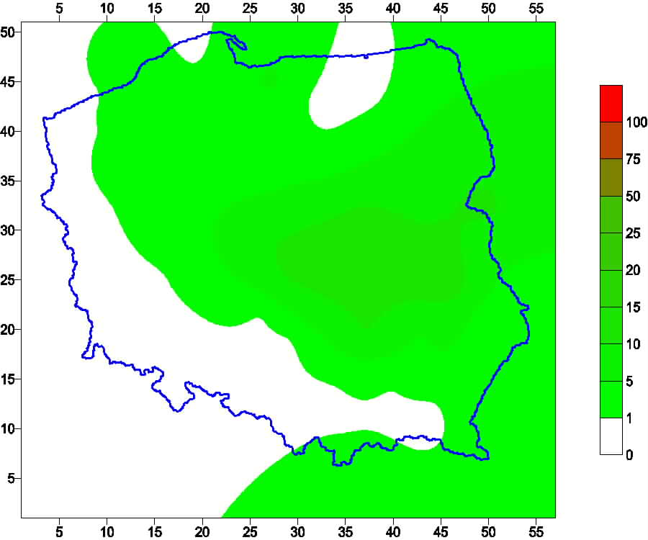
Fig. 2a. Total precipitation (mm) observed at synoptic stations, May 4th (left) and May 5th (right) – first and second day of forecast
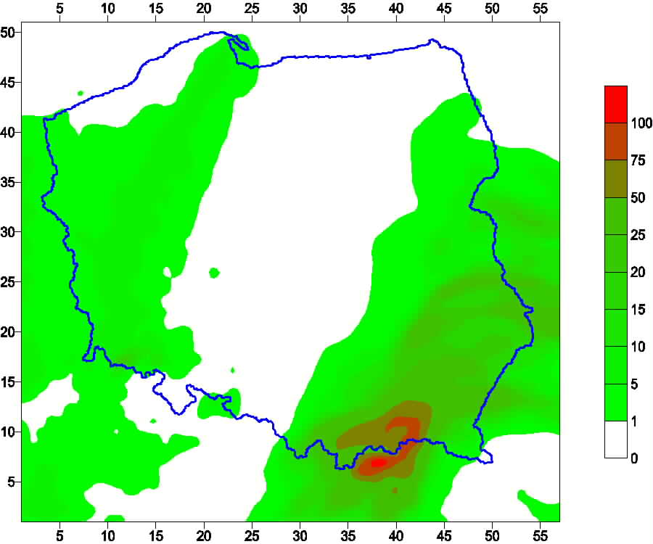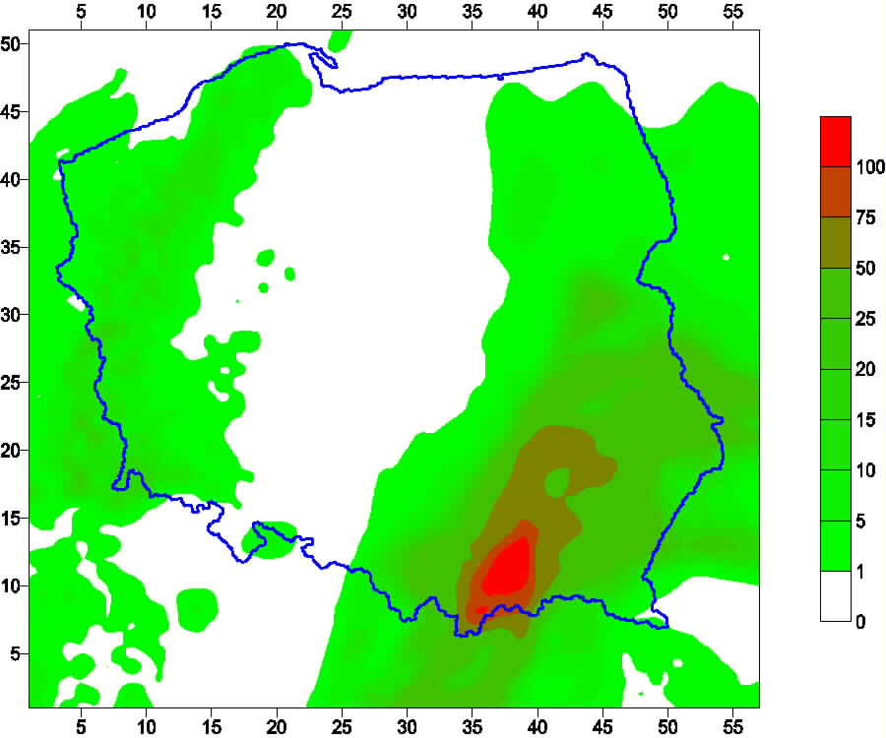
Fig. 3. Total precipitation (mm) forecast, June 10th, first day of forecast
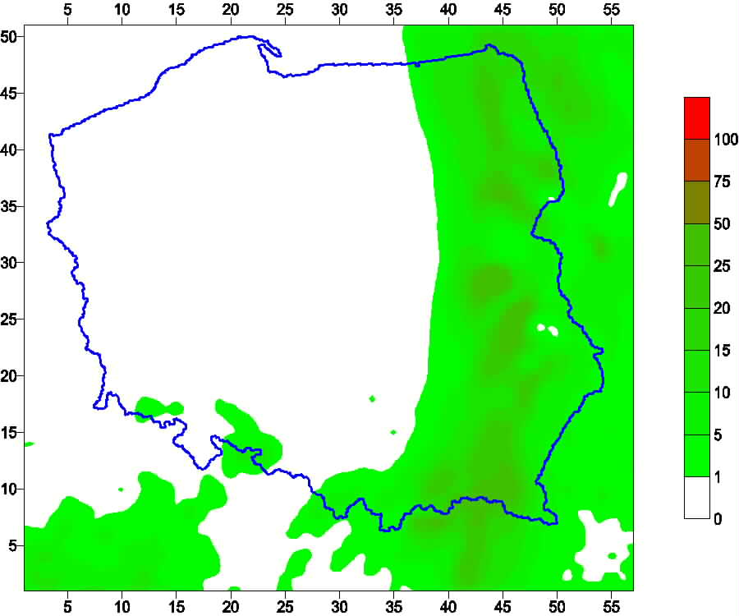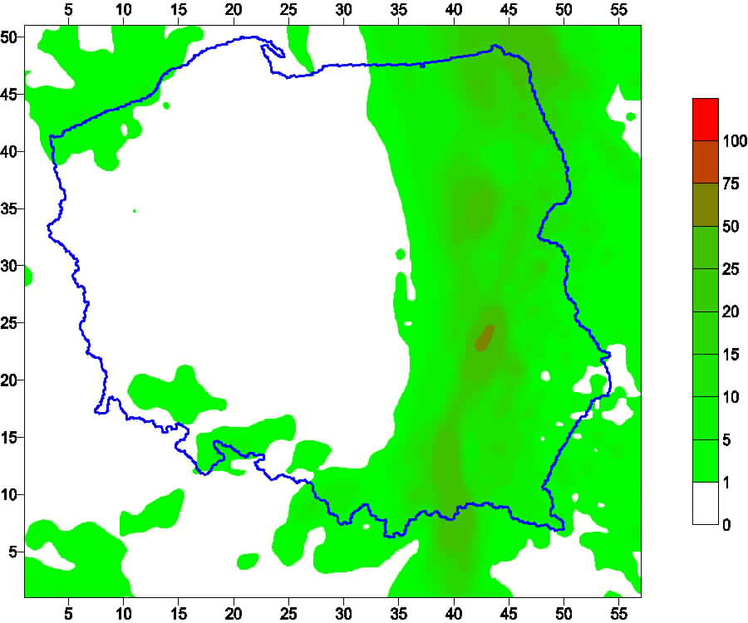
Fig. 4. Total precipitation (mm) forecast, June 10th, second day of forecast
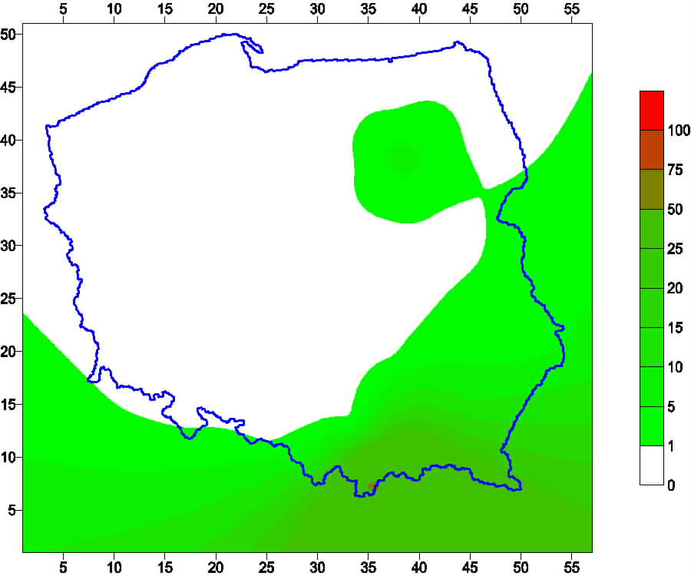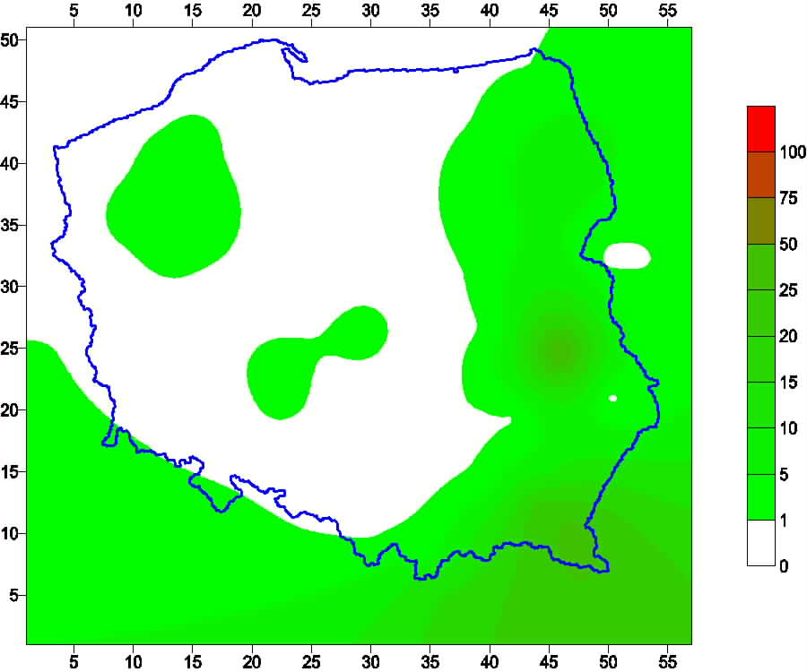
Fig. 4a. Total precipitation (mm) observed at synoptic stations, June 10th (left) and June 11th (right) – first and second day of forecast
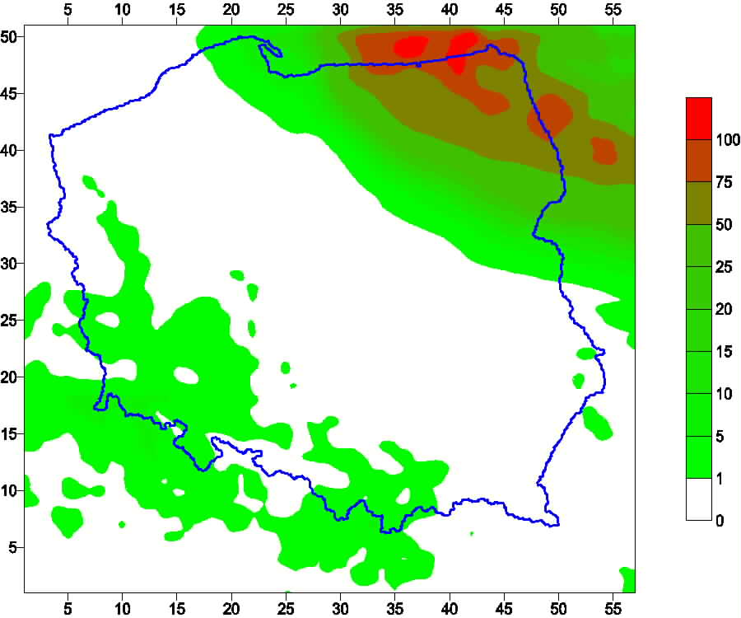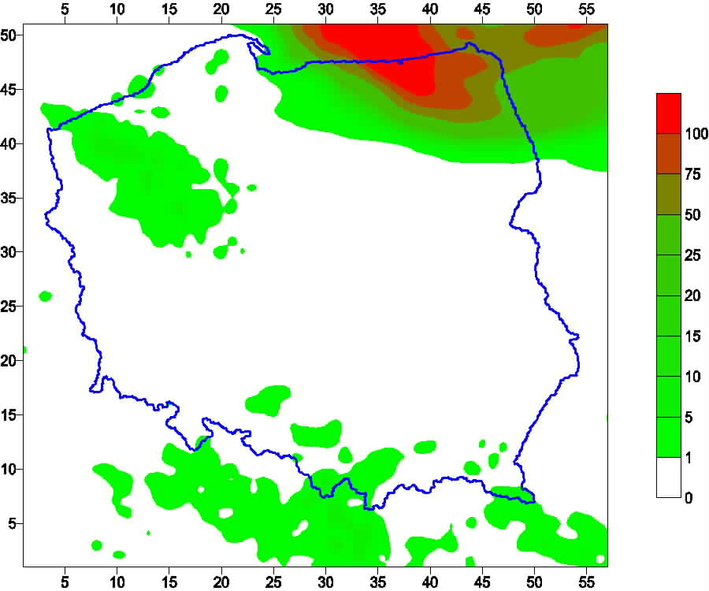
Fig. 5. Total precipitation (mm) forecast, August 9th, first day of forecast
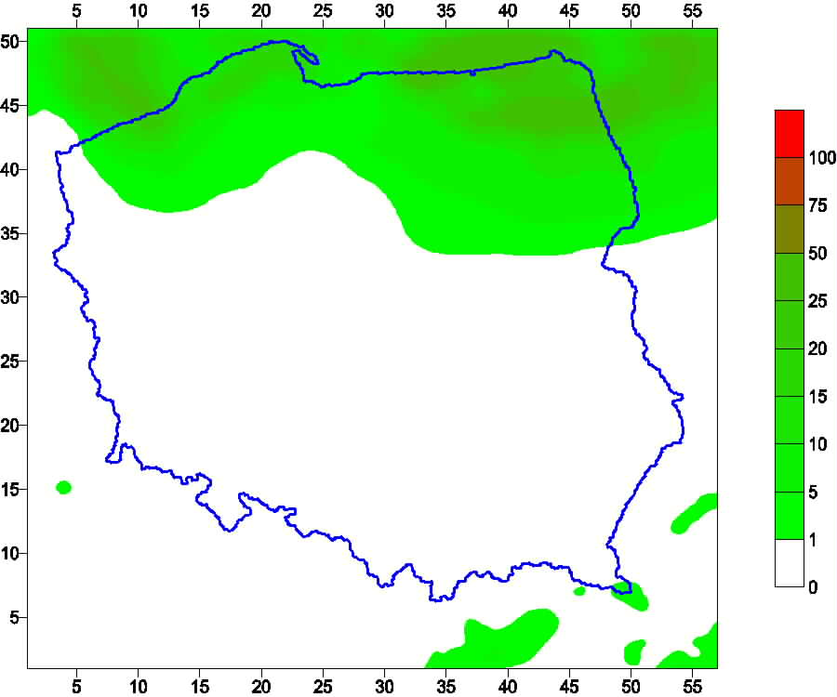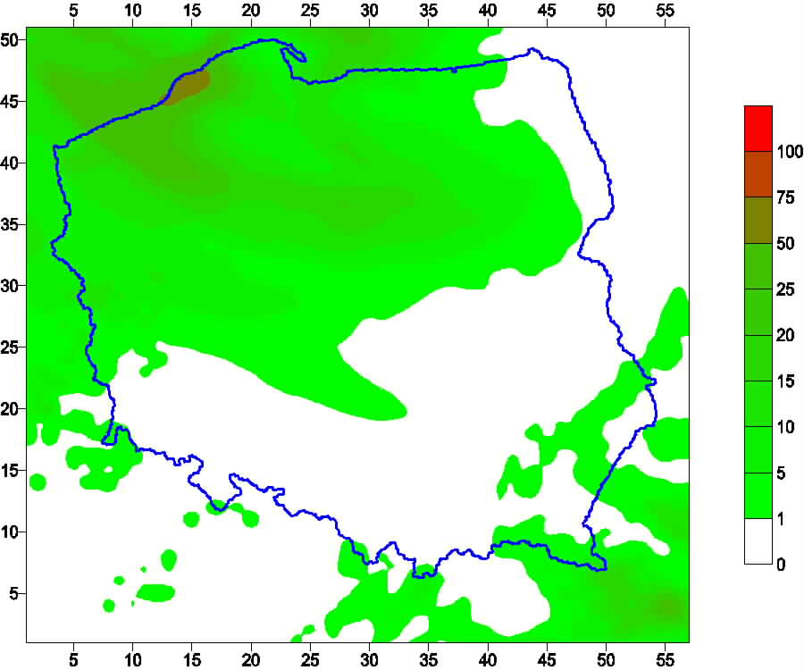
Fig. 6. Total precipitation (mm) forecast, August 9th, second day of forecast
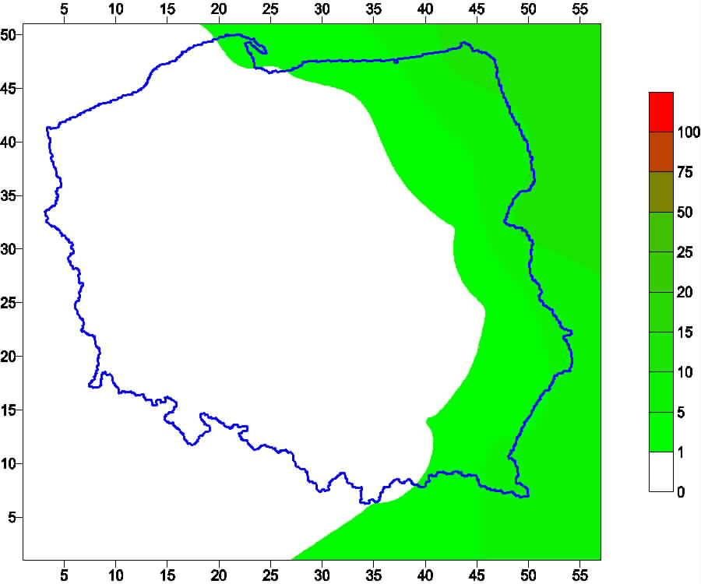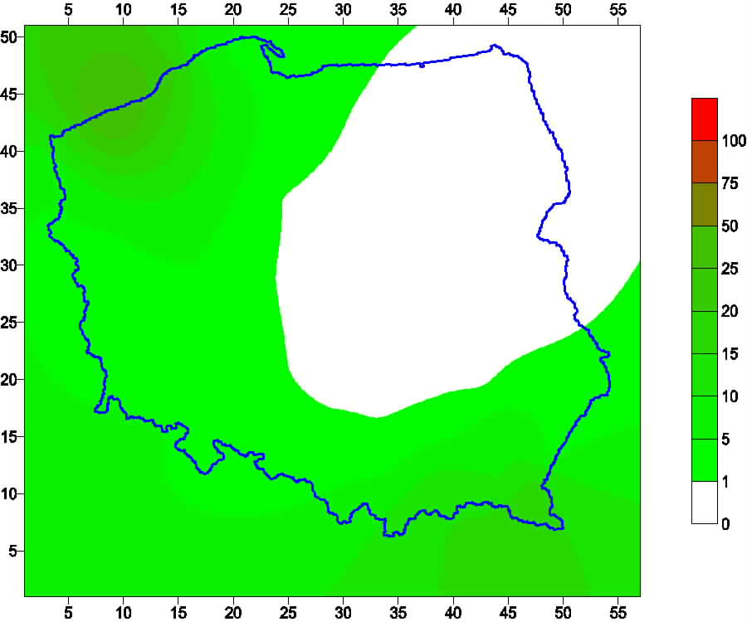
Fig. 6a. Total precipitation (mm) observed at synoptic stations, August 9th (left) and August 10th (right) – first and second day of forecast
Bias (LM-07 – LM-14) for chosen days looks like below:
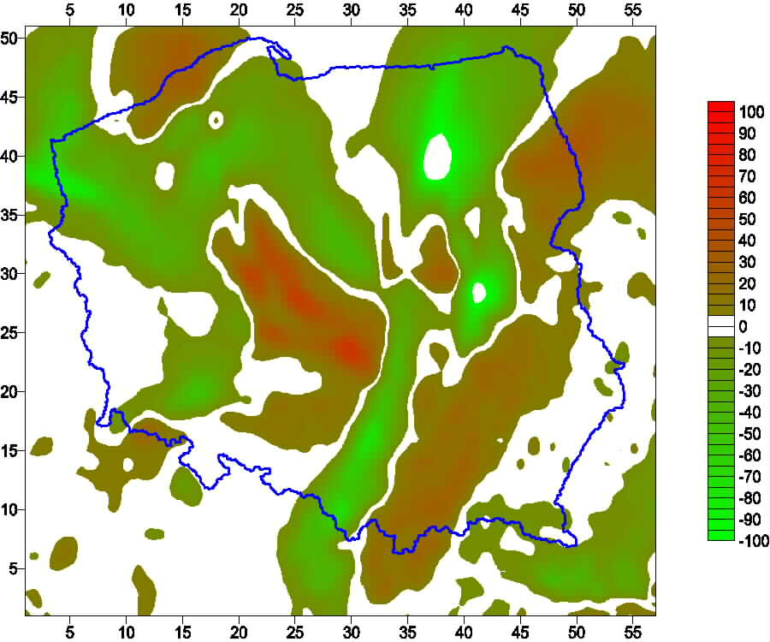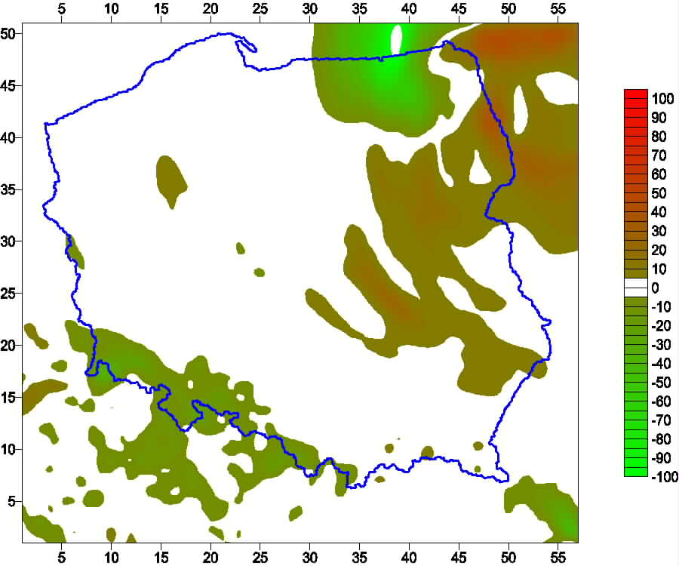
Fig. 7. Bias of total precipitation forecasts LM-07 – LM-14, May 4th, first (left) and second (right) day of forecast
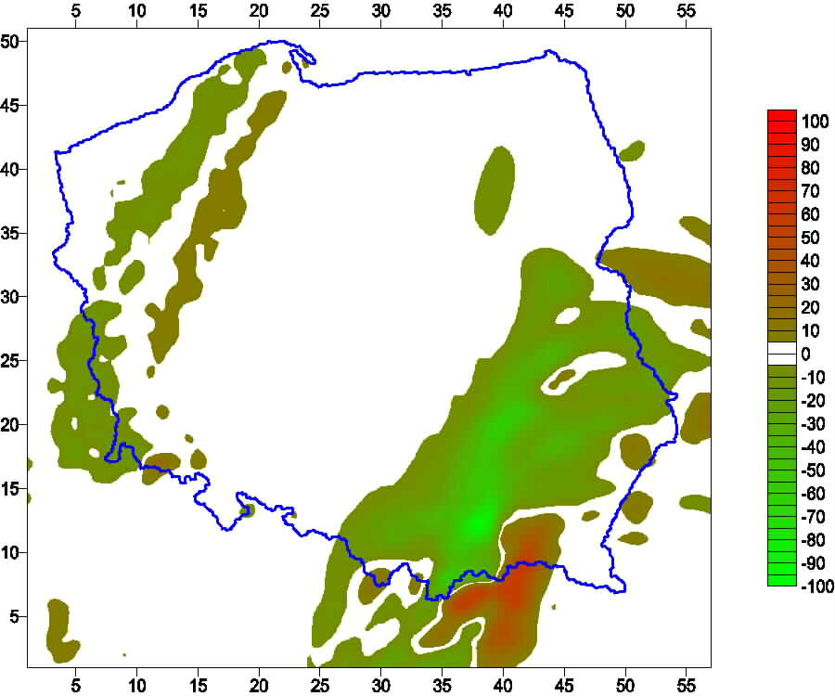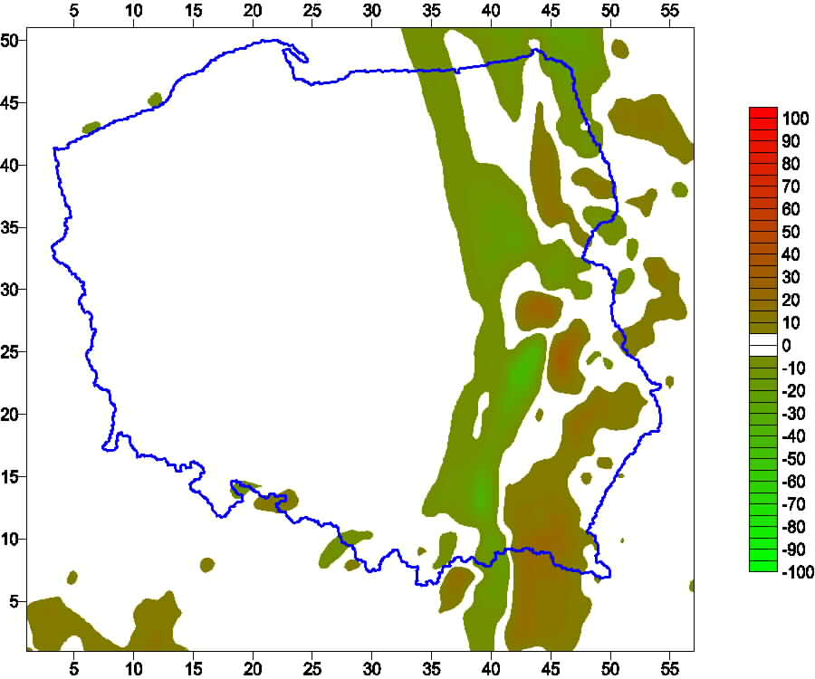
Fig. 8. Bias of total precipitation forecasts LM-07 – LM-14, June 10th, first (left) and second (right) day of forecast
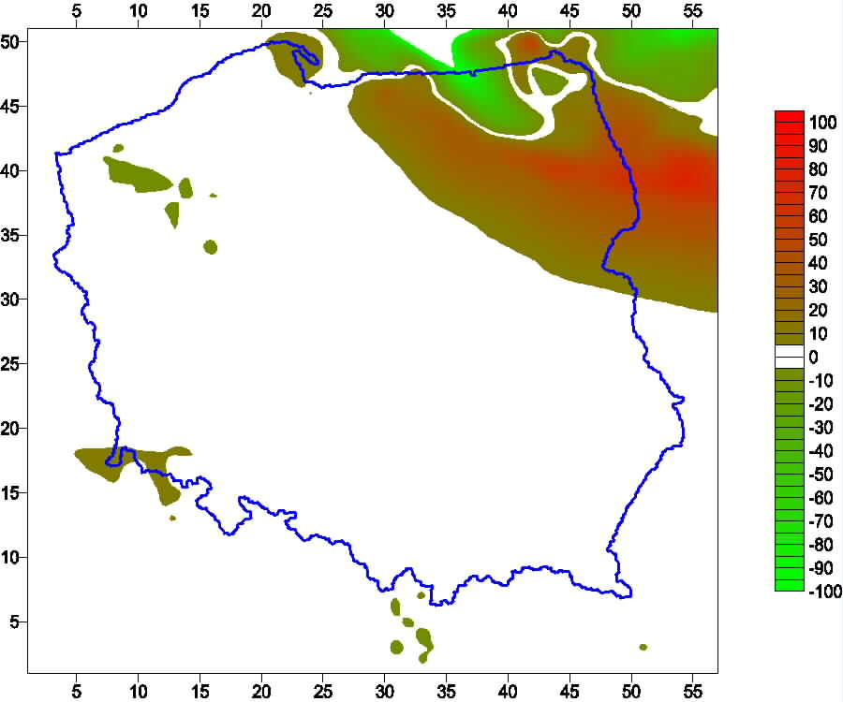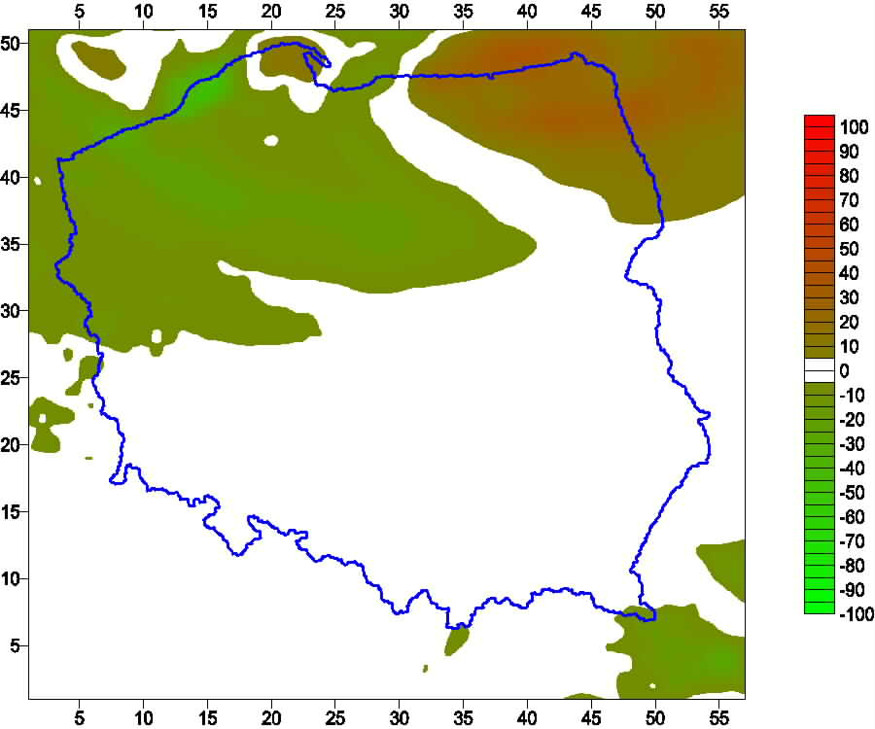
Fig. 9. Bias of total precipitation forecasts LM-07 – LM-14, August 9th, first (left) and second (right) day of forecast
When divided into grid-scale and convective part of precipitation, similar charts look like in following pictures.
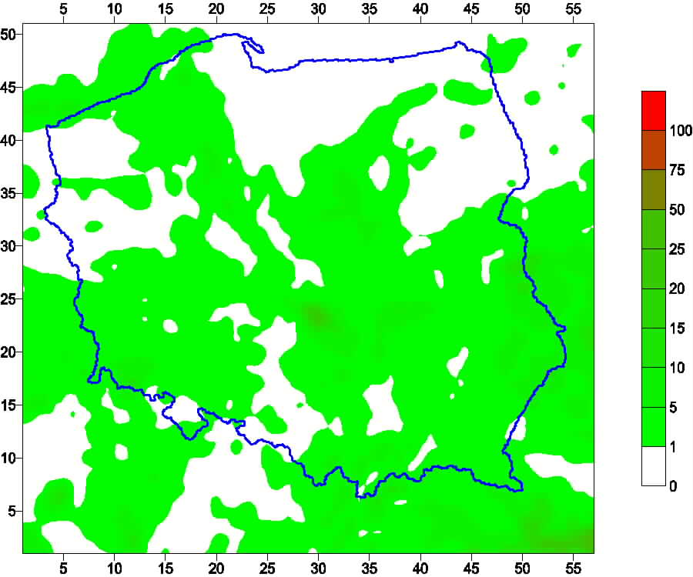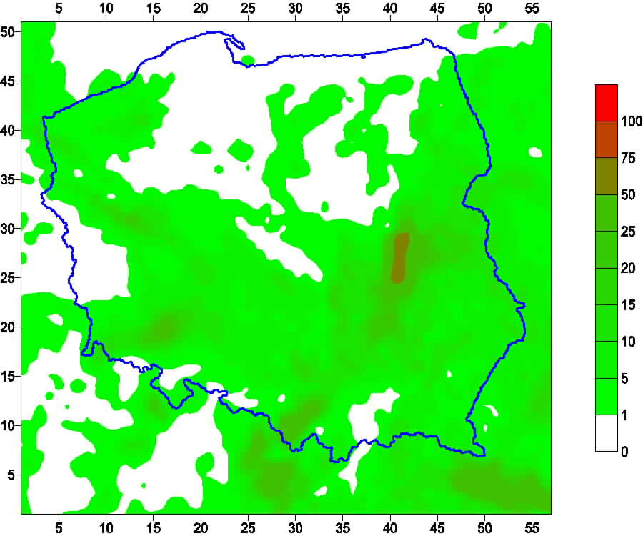
Fig. 10. Convective precipitation (mm) forecast, May 4th, first day of forecast
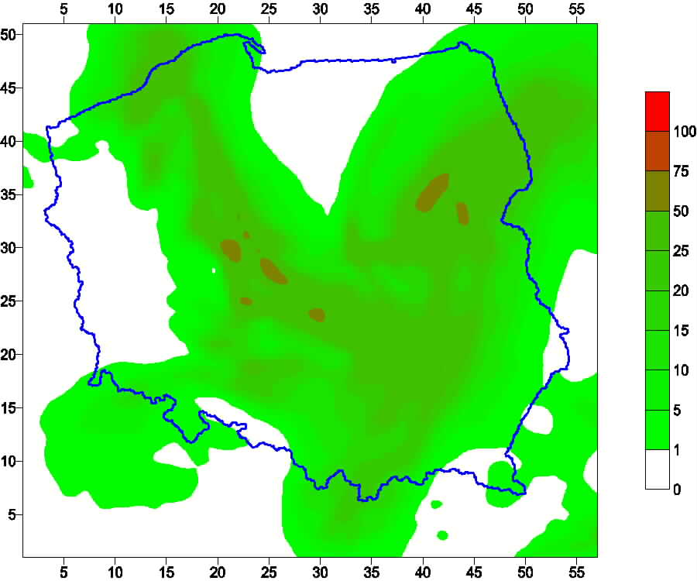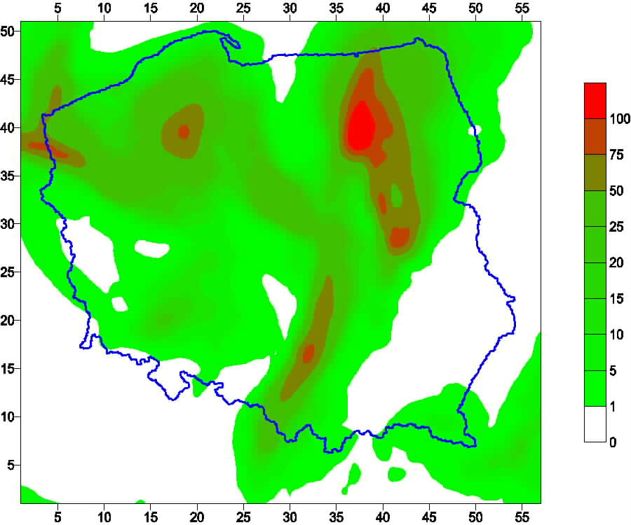
Fig. 11. Grid scale precipitation (mm) forecast, May 4th, first day of forecast
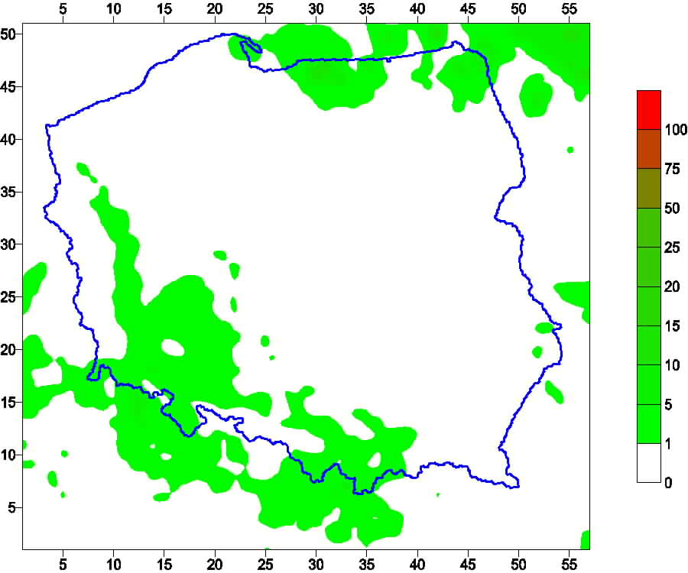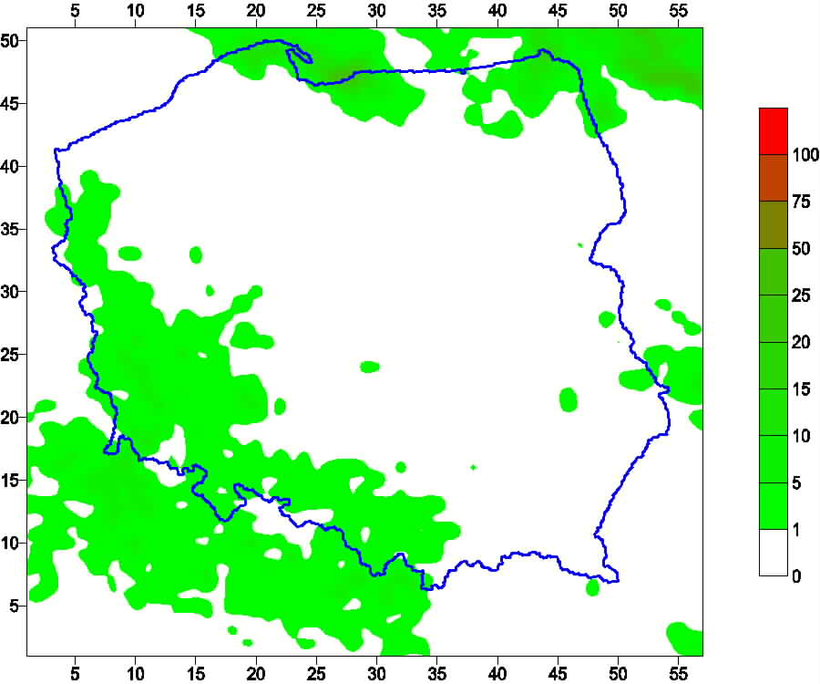
Fig. 12. Convective precipitation (mm) forecast, June 10th, first day of forecast
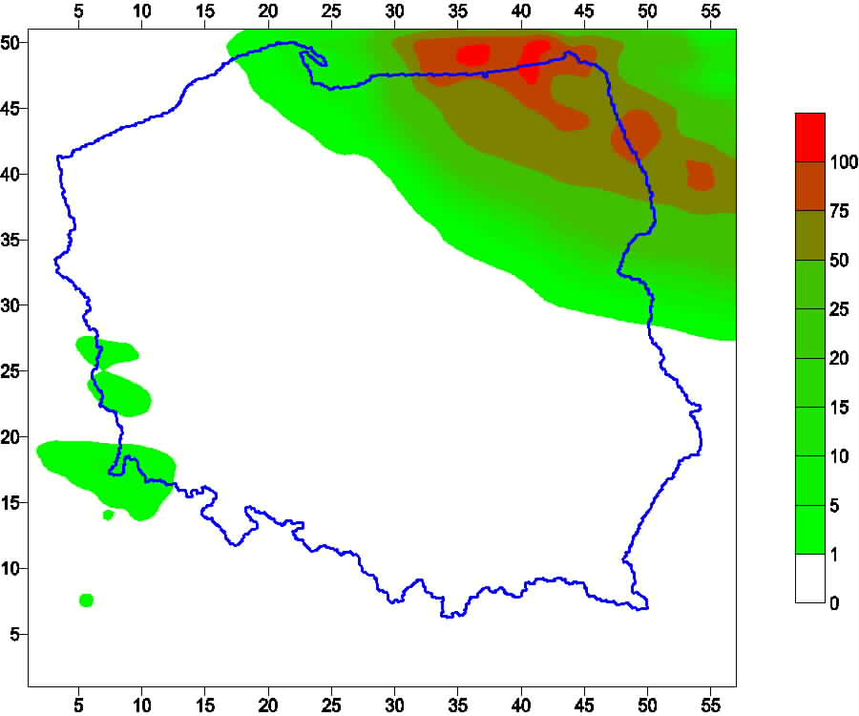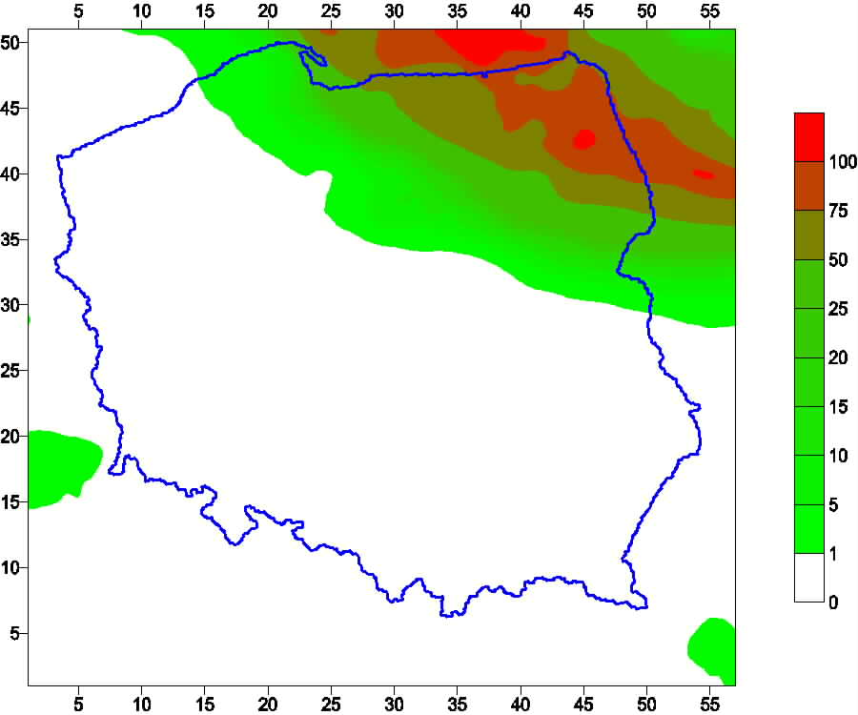
Fig. 13. Grid scale precipitation (mm) forecast, June 10th, first day of forecast
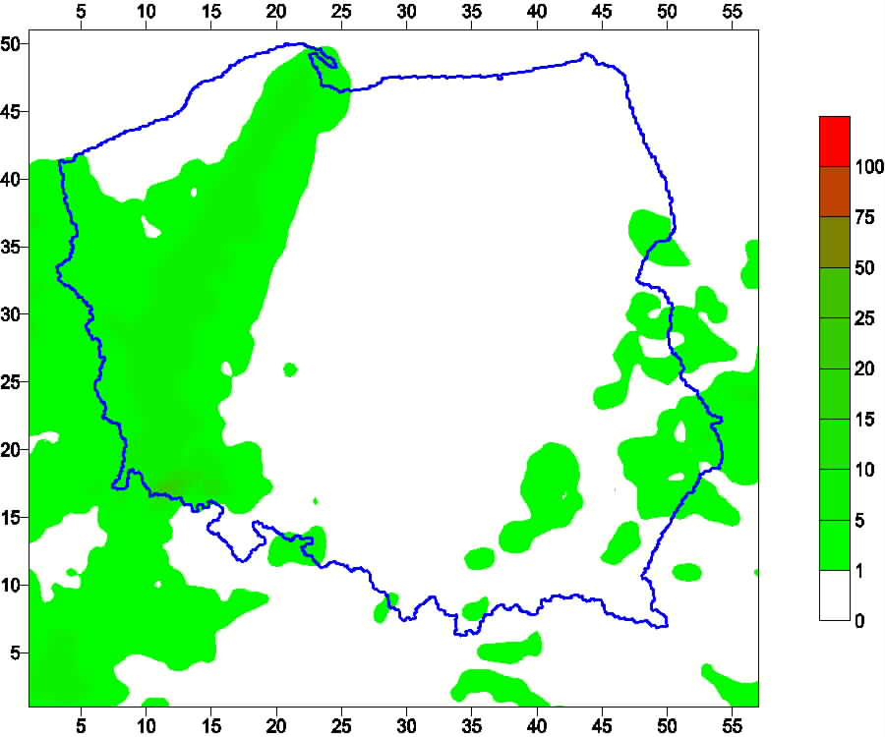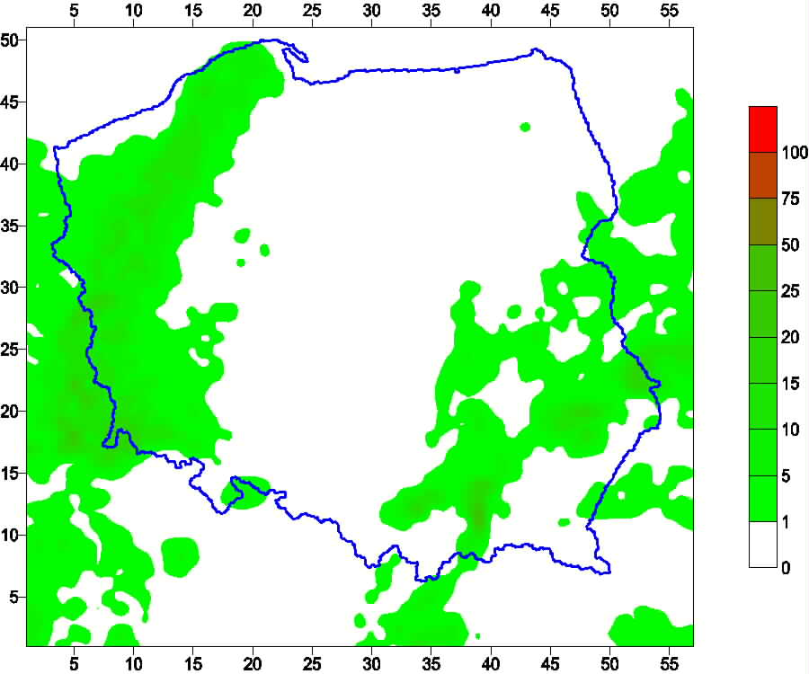
Fig. 14. Convective precipitation (mm) forecast, August 9th, first day of forecast
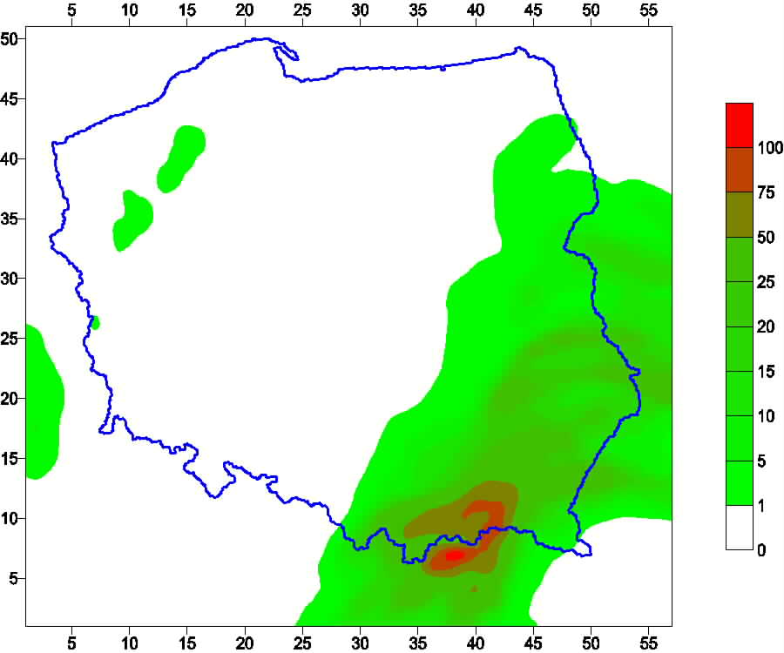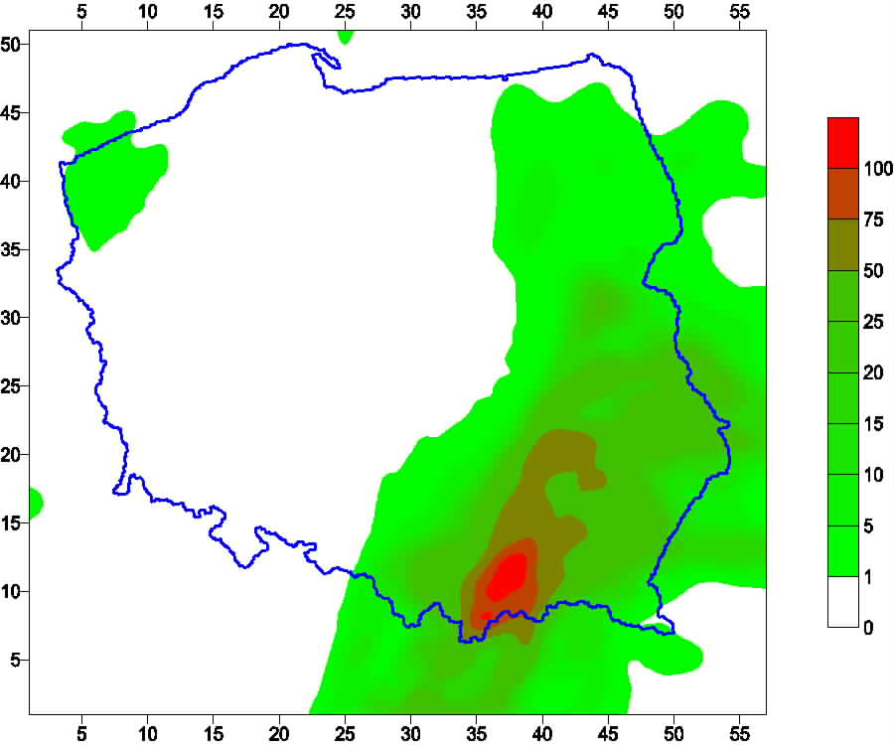
Fig. 15. Grid scale precipitation (mm) forecast, August 9th, first day of forecast

Mean biases, absolute biases and RMSEs for comparison are shown in the following table:
Table 1. Mean bias (LM-07 – LM-14), absolute bias and RMSE for chosen cases.
Date, day of forecast | Bias | Absolute bias | RMSE
May 4th, first day | -4.99 | 13.72 | 21.29
May 4th, second day | -0.51 | 5.75 | 12.13
June 10th, first day | -2.38 | 5.16 | 10.95
June 10th, second day | -0.42 | 3.09 | 5.71
August 9th, first day | 1.08 | 6.44 | 18.14
August 9th, second day | -1.53 | 5.47 | 9.08

Discussion
Taking all above into consideration, it seems that use of increased resolution domain in general may result in decreasing of absolute forecast amount, making it close to reality, especially in a case of a “huge precipitation” forecasts. The difference was found to be not that big when small amount of precipitation was predicted.
Except for one case (August 9th, first day of forecast) bias is negative, which may support the above idea. Moreover, patterns of distribution of precipitation for both resolution – in general – looked similar to each other. Still, extreme values looked sharper in lower resolution. Comparing all model forecasts – LM-07 and LM-14 – with observed precipitation (“a” pictures) one may say that in general both types of forecast overestimates precipitation amount, sometimes (LM-14) even by a factor of ten, especially in a grid-scale part. So, increased resolution results in – obviously – close approach to reality. However, (increased and massive) numerical costs of increased resolution are not negligible. Further investigations will be carried out to establish if there is any simple technique that would be sufficient and adequate to circumvent this problem. Preliminary tests showed however that more sophisticated methods should be applied, since, for example, interpolation combined with spline smoothing didn’t seem to be good solution for the problem.
2. Operational correction of "raw" precipitation output from the model using filtering and/or adaptive techniques for point locations.

Summary
For hydrological applications mainly two basic data sets (forecasts) are required: (i) precipitation (water) and (ii) temperature forecasts. We prepared system for automatic correction of both of these data, based on adaptive regression scheme. Main (independent) variables are coordinates, elevation and previous forecast and measurement results. The system works as follows: (1) it gathers data from measurements at SYNOP stations; (2) regression coefficient are calculated using these data and model results for locations of stations (3) appropriate - corrected - forecasts of temperature and precipitation are stretched out from stations to all points (via relation with coordinates) covering, for example, a selected catchment in the (near) vicinity of a station. Of course, results are significantly better for temperature than for precipitation due to its specific character. Still, the more results we shall collect, the better correction we will achieve. Every forecast (even numerical forecast) comes with an error. Especially it can be seen when we are talking about point forecast (for instance, at meteorological stations). In such a point location a quality of forecast may be easily verified.

Methods and results
The Adaptive Regression technique, as a variation of a Kalman filtering procedure, was described by E. Kalnay (Numerical Weather Forecasting and Predictability). It is based on known values of observations and on previous forecasts, combined to obtain a new forecast in a near future. Results are shown in following pictures.
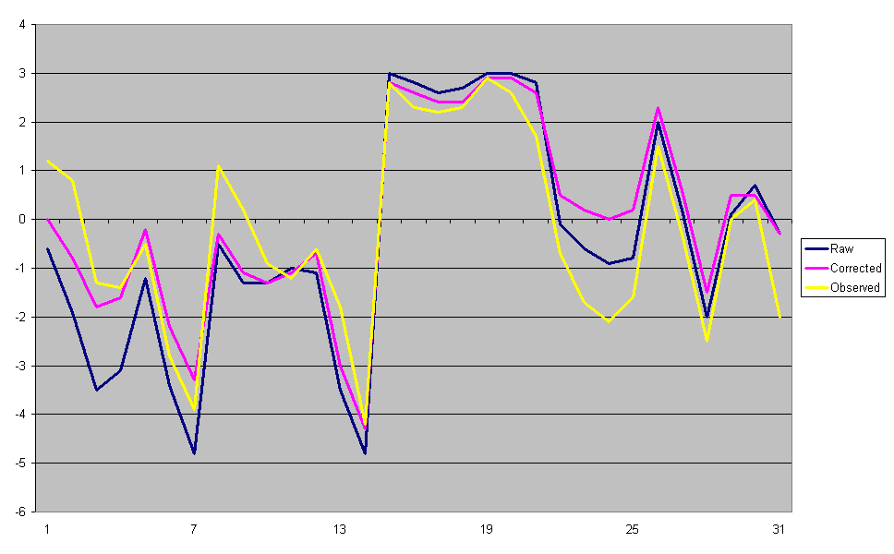
Fig. 16 Example of “raw” and “corrected” results of temperature forecast vs. observed values
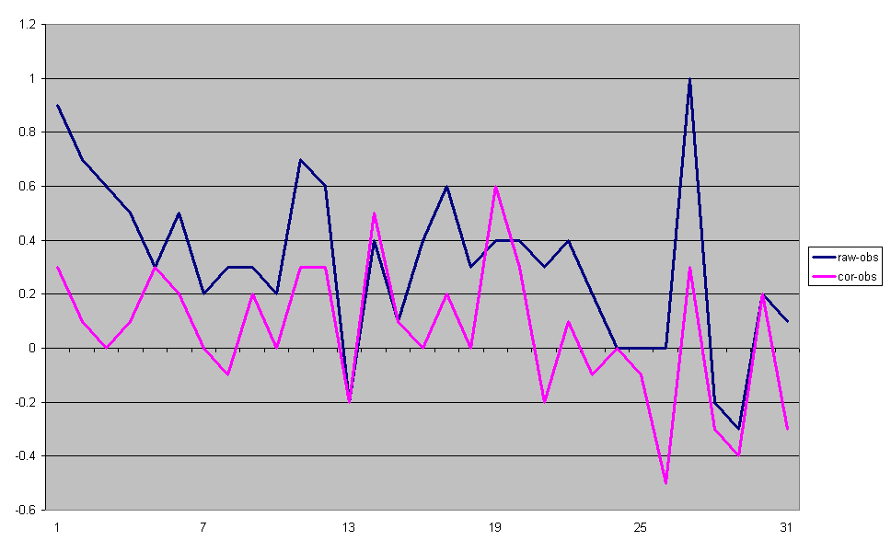
Fig. 17 Example of residual values – “raw-obs” and “cor-obs” of temperature forecast
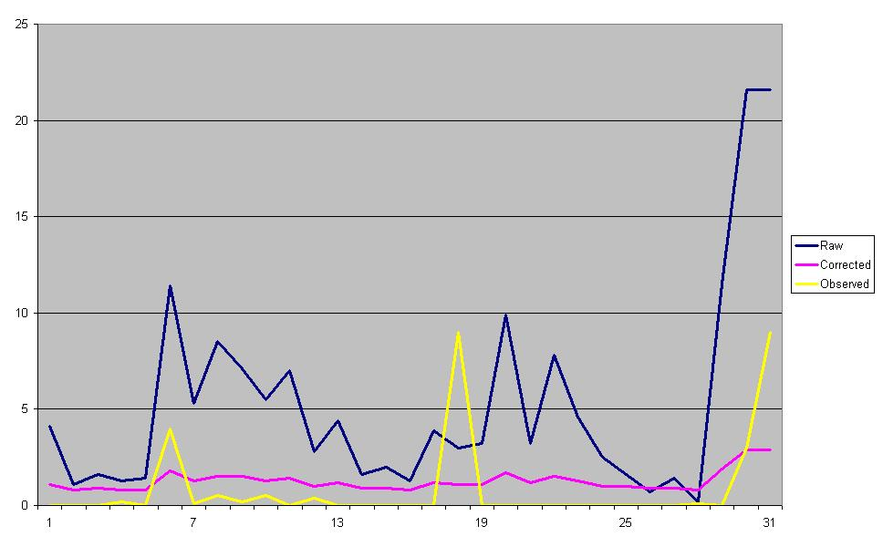
Fig. 18 Example of “raw” and “corrected” results of precipitation forecast vs. observed values
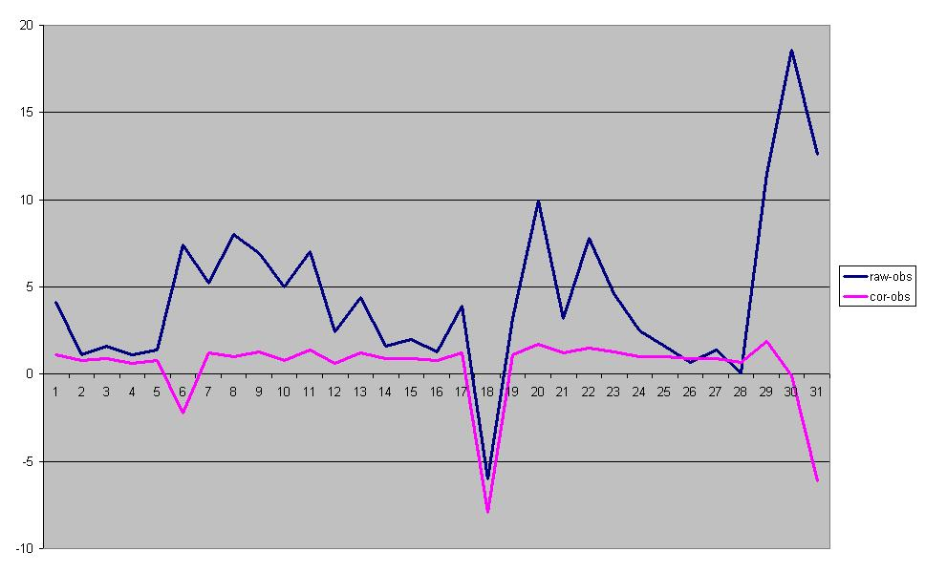
Fig. 19 Example of residual values – “raw-obs” and “cor-obs” of precipitation forecast

Discussion
Basic analysis of “raw” model results showed that they of course differ from point measurements. So, an application of “some” additional procedure seemed to be necessary. As the beginning, simple Kalman filtering (Adaptive Regression method) was suggested. It seems to work quite good as far as continuous meteorological parameters, like temperature, wind speed or air pressure, are concerned.
Application of filter for raw model results have some characteristic features. First of all, it seems to work quite good as far as continuous meteorological parameters (like temperature) are concerned. Moreover, results seem to depend on differences between observations and “raw” results (i.e., BEFORE filter is applied). In other words, the greater difference - the better result. Results for precipitation are not that good, however, they are not very bad either. Due to different “nature” (than the one of temperature) different approach was applied – smaller amount of predictors, shorter “teaching” period etc. Yet, some sharp patterns of “raw” precipitation forecasts seem to be smoothed down, to be closer to reality.
This system is working in an operational manner and the results are ready to be picked up two times every day.

Literature
Kalnay, E.: Numerical weather forecasting and predictability. Cambridge University Press, 2001
Mierkiewicz, M. and Parfiniewicz, J.: The COSMO_LM_PL Precipitation Forecasts are verified on Daily Rainfall data Averaged over Selected River Basins, COSMO Newsletter No.4, 2004
Mierkiewicz, M., Żelazinski, J. and Parfiniewicz, J.: The LM_PL14 and LM_PL07 Model Forecasts as Input into a Hydrological Forecasting Model
Ott, E., Hunt, B., Szunyogh, I., Zimi, A.V., Kostelich, E.J., Corazza, M., Kalnay, E., Patil, D.J. and Yorke, J.A.: A local ensemble Kalman filter for atmospheric data assimilation. Tellus 56A (2004), 5
Sorenson, H.W.: Least-squares estimation: from Gauss to Kalman. IEEE Spectrum 7, 1970

