The new LM climate mode (CLM)
and the behaviour of the deep soil TERRA3D

A. Will, A. Block, K. Keuler

Brandenburgische Technische Universität Cottbus, Burger Chaussee 2, Haus 4/3, 03044 Cottbus, Germany

- Introduction

In 2001, LM was chosen as the basis for a new regional climate model called CLM. Although at this time numerous regional climate models already existed, there were at least two reasons for this decision. First, the non-hydrostatic formulation of the dynamical equations in LM without any scale assumptions made it eligible for use at horizontal grid resolutions of about 20 km and below, coming closer to the spatial scales requested by modelers of regional climate impacts. Secondly, the continuous development of LM at the DWD and in the COSMO Consortium allows improvements in major LM versions to be adopted in the climate version ensuring that the central core is not a “frozen” one, but that of an up-to-date “living” forecast model. Meanwhile, we have succeeded in implementing extensions for long-term simulations into LM and in applying and evaluating the resulting CLM for multi-year climate reconstructions over Europe. Vice versa, these “climate mode” extensions will be made available in the forecast model as a new feature of LM 4.1.
For a brief description of the major extensions implemented in LM 2.19 to obtain the CLM version 2.0, its standard evaluation the model's performance in comparison with the ECMWF (European Centre for Medium-Range Weather Forecasts) analysed data, with observations and with other regional climate model results we refer to the COSMO Newletter 6 (2006). During the last months the climate mode has been made available within the recent LM model version. The tests of the new hybrid LM4.1/CLM4.1 model version are in progress.

- Short description of the method of Climate Statistics

The key feature of the climate mode is the possibility to conduct transient model simulations over time scales of months, years and decades, which is much longer than the typical period of weather forecast. This opens the possibility to analyze the relevance of the model physics independently of initial conditions and the data assimilation procedure on different time scales.
In the weather forecast mode, the soil of the model is initialized days, months or years in advance and develops without further initialization or data assimilation. In this respect the operational weather forecast and the regional climate prediciton are identical. Even if the possible forecast time is 72 h only, it is influenced by the state of the deep soil and by the long time behavior of the soil model. Here the climate mode opens new possibilities to analyze the relevance of the soil model for weather prediction.
In comparison with the operational weather forecast the climate mode allows the integration of the model over time scales of up to 150 years without any initialization of the atmosphere or soil. The statistics of a climate simulation exhibits therefore the properties of the model physics and of the boundary conditions with no influence of the initial conditions and of the data assimilation system.

- Aspects of the behavior of the soil model relevant for weather prediction

During the last two years we conducted a couple of tests using the CLM2.x model version, different driving data sets and the deep soil model TERRA3D. The analysis of the results and their inter comparison exhibits new insights into the properties of the soil model TERRA3D with respect to the water cycle and heat conduction in the soil and the relevance of initial conditions of the soil model for weather and climate.

One open question is on the influence of the date of the initialization of the soil on the weather forecast. Figure 1 shows the difference between two simulations at 12.00 of 2nd and 4th July 1979. The first simulation has been started with a climatological soil at 0.00 of 1.7.1979 and the second at 0.00 of 1.6.1979. The inter comparison of the simulations show a strong influence of the initial conditions of the soil on the weather in the climate mode.
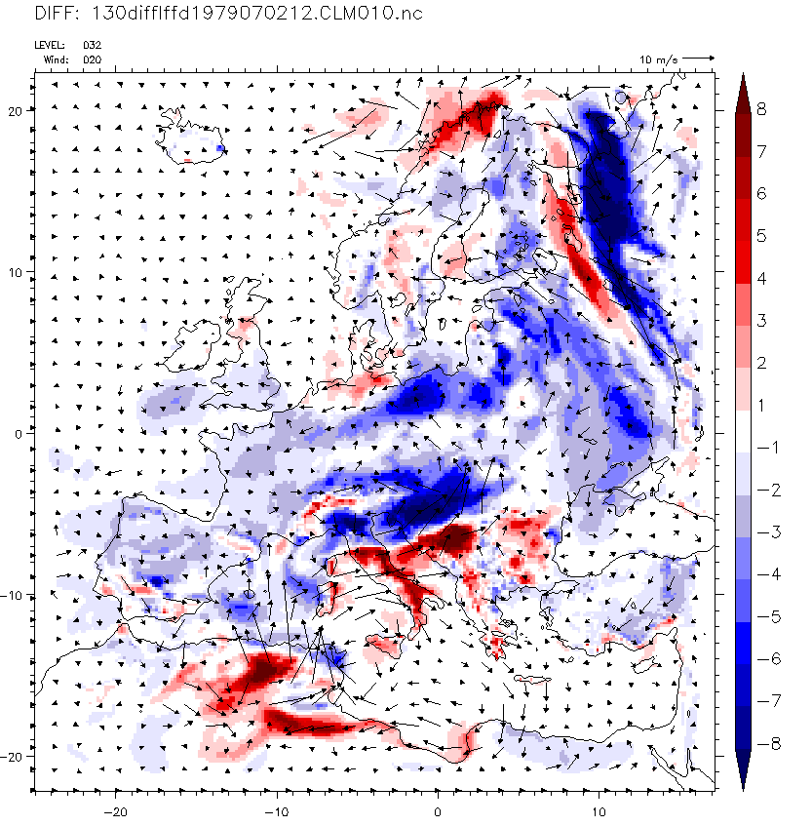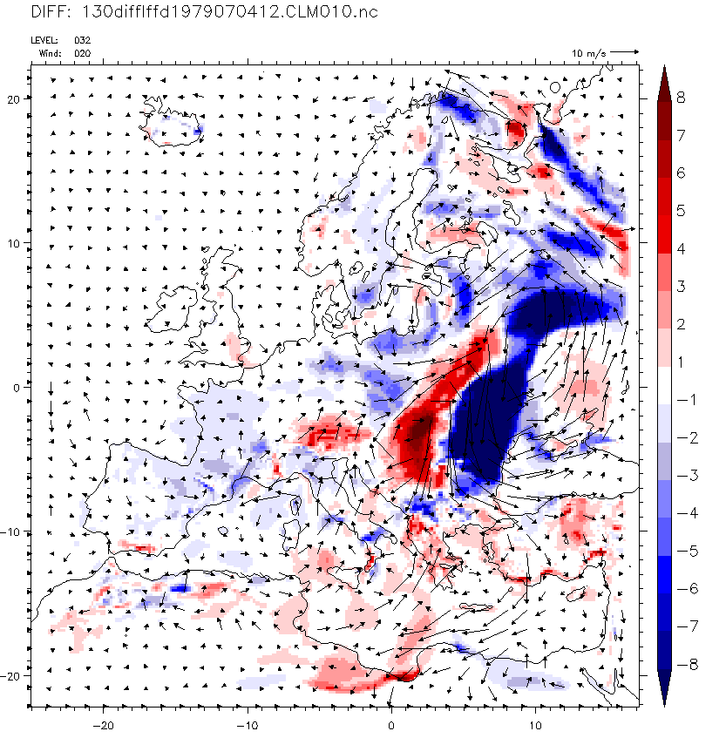

Figure 1: Differences of surface Temperature and 800 hPa wind for two dates in July1979 between simulations started at 1.7.1979 and 1.6.1979 and ERA40 boundary data, Δx= Δy=18km, 32 levels. Left: July 2nd 12.00 Right: July 4th 12.00.

- Summary and Outlook

We present results on different aspects of the soil model as revealed in the climate mode like relevance of initial conditions, surface energy budget, heat and water transport in the soil, discuss the relevance of the results for weather prediction and regional climate modelling and give an overview of work in progress within the CLM-Community related to the soil model.

