Evaluation of the Kain-Fritsch/Bechtold convection scheme

Silke Dierer and Francis Schubiger
Federal Office of Meteorology and Climatology, MeteoSwiss, Switzerland

1. Introduction

Horizontal resolution of today’s operational weather prediction models is not yet high enough to resolve convection. Schemes to parameterize convection differ regarding the trigger function forcing the onset of convection, the closure assumption and the cloud model. The operational runs of the alpine model (aLMo), the Swiss implementation of LM, are performed using the mass-flux scheme developed by Tiedtke (1989). The scheme is based on a moisture convergence closure and was originally developed for applications on the global scale. For simulations with much smaller grid sizes (e.g. 7 km) a convection closure based on convective available potential energy (CAPE) - as used in the scheme by Bechtold et al. (2001) - might be more suitable.

Both convection schemes, the Tiedtke and the Kain-Fritsch/Bechtold (KF/B) scheme, are mass flux schemes. The main difference is the closure aussumption that is based on moisture convergence in the Tiedtke scheme and on CAPE in the KF/B scheme. Besides, the two schemes differ regarding the trigger mechanism. In the Tiedtke scheme convection is triggered if the parcel’s temperature exceeds the environment temperature by a fixed temperature threshold of 0.5 K. In the KF/B scheme the onset of convection depends on the large-scale vertical velocity. The Tiedtke and the KF/B scheme distinguish penetrative and shallow convection. The Tiedtke scheme additionally considers mid-level convection, convection starting above the planetary boundary layer. This is not separately considered in the KF/B scheme since the trigger criterium is also applied above the PBL. The major differences between the schemes are shown in Table 1.

 | Tiedtke scheme | Bechtold scheme
Trigger | - Near surface  -Updraft source layer ~model layer thickness  - Fixed value for Δ T | - Near surface and upper levels  - Updraft source layer ~60 hPa  - Δ T = f(w)
Closure | - Moisture convergence closure | - CAPE closure
En-/Detrainment | - Turbulent mixing and organized inflow | - Turbulent mixing
Table 1: Major differences between the Tiedtke and the Kain-Fritsch/Bechtold scheme.

The KF/B scheme was implemented in LM-Version 3.18. Preliminary tests were performed by simulating several cases of summer convection. The results are compared to results with Tiedtke scheme and to measurements. Compared to simulations with Tiedtke scheme the simulations with KF/B scheme tend to have higher average but lower maximum values of 24 hour precipitation. Both schemes overestimate precipitation, but the 12hours-sum of precipitation are slightly better with the KF/B scheme. The maximum of the daily precipitation cycle is delayed by about 2-3 hours resulting in a better agreement with the measured precipitation cycle. A quasi-operational test chain using the KF/B scheme was set up end of May. The comparison of its results with measurements for wind, temperature, humidity, cloud cover and precipitation is described in Section 2. Conclusions and outlook are given in Section 4.

2. Results of the test chain with the Kain-Fritsch/Bechtold scheme

2.1. Description of the test chain with Kain-Fritsch/Bechtold scheme

The test chain using the KF/B scheme runs in a quasi-operational mode, equivalent to the operational run for 00 UTC. Initial conditions are taken from the operational assimilation run using the Tiedtke scheme and lateral boundary values are interpolated from IFS data. The simulation period is 72 hours. The results of the operational runs and of the KF/B test chain are evaluated by comparison with the ANETZ measurements for June and July 2006.

2.2. Diurnal cycle of precipitation and cloud cover

The runs with Tiedtke and with KF/B scheme overestimate the measured precipitation. The overestimation is higher in the simulations using the KF/B scheme, mainly due to overestimation in flat regions (Figure 1, lower panel, left). The frequency bias (Table 2) shows that the runs with KF/B scheme overestimate thresholds of 0.1 and 2 mm by nearly 100%. The overestimation of light precipitation is remarkably lower for the operational run. Accordingly, false alarm rates for thresholds 0.1 and 2 mm/6h are higher for the KF/B scheme.

The number of observed cases with thresholds of 30 and 50 mm/6h is 42 and, thus, small. The operational runs show 79 cases, the runs with KF/B show just 29. The operational runs strongly overestimate higher thresholds (30 and 50 mm/6h), resulting in a high false alarm rate (Table 3). This overestimation results from mountainous regions, especially from the height level between 800 m and 1500m. The runs with KF/B scheme underestimate precipitation sums with threshold 30 mm (Table 2). The two schemes are more similar in regions where precipitation is strongly influenced by orography (Figure 1, lower panel, right).

The diurnal cycle of precipitation is too early in the operational runs and in the runs with KF/B: precipitation starts about 6 hours early and reaches its maximum too early. The simulations with the KF/B scheme show a better agreement with the measurements, since the maximum of precipitation occurs about 2 hours later than in the operational runs. The time shift mainly occurs in flat areas, where the temporal development of precipitation is in very good agreement with the measurements (Figure 1, lower panel, left). For stations above 1500 m precipitation starts about 6 hours too early and the influence of different convection schemes is negligible.

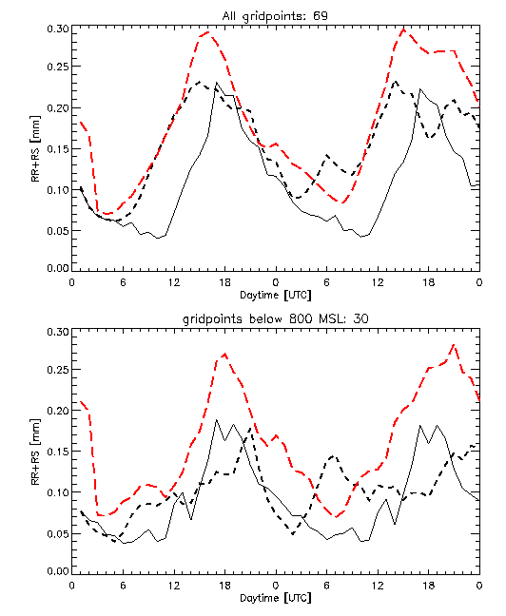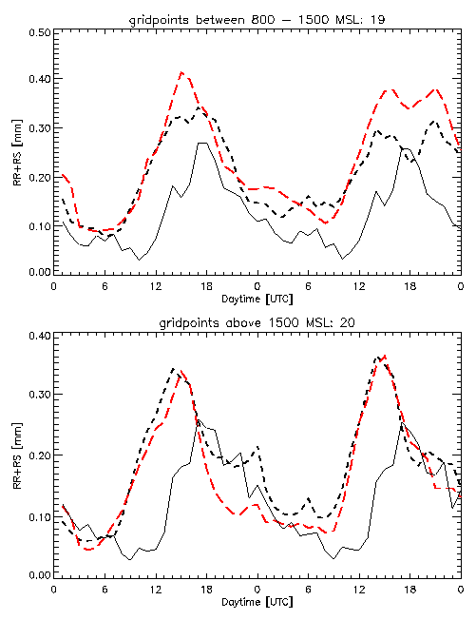
Figure 1: Diurnal cycle of precipitation of all stations (upper panel, left), stations below 800m (lower panel, left), stations between 800m and 1500m (upper panel, right) and above 1500m (lower panel, right). The figure shows measurements (black line), results with the Tiedtke scheme (black dashed line) and results with the KF/B scheme (red dashed line).

The simulations with KF/B scheme show enhanced precipitation during the first hours of the simulation (Figure 1, upper panel, left), mainly caused by precipitation in flat regions. The assumption that the spin up effect might be caused by taking initial conditions from the operational assimilation run using the Tiedtke scheme was investigated. A period with enhanced precipitation in the first few hours (5th to 7th of July 2006) was simulated using an assimilation run with KF/B scheme. Taking the initial conditions from the assimilation run with KF/B scheme did not solve the problem of enhanced precipitation at the beginning of the simulation. Further investigations revealed that precipitation is strongly overestimated in the first 3 hours in regions that provide conditions for convection. Thus, the location of precipitation is correct, but the amount of precipitation is by far overestimated. After the first 3 hours the simulated precipitation amount is reasonable. Further investigations are carried out in order to prevent the spin-up effect.

Frequency bias, threshold [mm/6h] | operational | Kain-Fritsch/Bechtold
0.1 | 169 | 194
2 | 141 | 192
10 | 117 | 115
30 | 188 | 70
50 | 833 | 133
Table 2: Frequency bias for the simulations with Tiedtke and KF/B scheme.

False alarm rate, threshold [mm/6h] | operational | Kain-Fritsch/Bechtold
0.1 | 58 | 61
2 | 68 | 73
10 | 82 | 84
30 | 98 | 93
50 | 100 | 100
Table 3: False alarm rate for the simulations with Tiedtke and KF/B scheme.

The diurnal cycle of cloud cover is not reproduced by the operational run and neither by the run with KF/B scheme. There is hardly any diurnal cycle in the results with both schemes. After 15 hours simulation time, when convection starts, the cloud cover in the runs with KF/B scheme gets about 0.5 octa smaller than in the operational runs. The deviation remains constant for the rest of the simulation. The operational runs tend to overestimate cloud cover during night and runs with KF/B tend to underestimate cloud cover during day. The bias of cloud cover is in a similar range for both schemes.

Preliminary investigations show that the main difference occurs for high clouds. For the results with KF/B the cloud ice tendency calculated within the convection scheme was not used for the prognostic cloud ice calculation. This deficiency was corrected and its impact was tested by comparig some case studies with and without consideration of convective cloud ice tendency. The effect was very small and could not explain the difference between the runs with Tiedtke and KF/B scheme. Further investigations are carried out in order to understand the cloud cover differences.

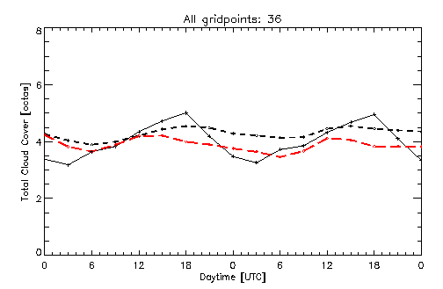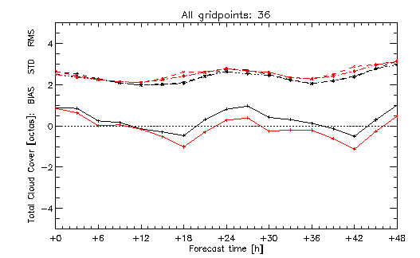
Figure 2: Diurnal cycle of cloud cover (left) and diurnal cycle of cloud cover bias, standard deviation and root mean square error (right).Left: the figure shows measurements (black line), results with Tiedtke scheme (black dashed line) and results with KF/B scheme (red dashed line). Right: the figure shows bias (full line), standard deviation (dashed dotted line) and root mean square error (dashed line) of results with Tiedtke scheme (black) and KF/B scheme (red).

2.3. Diurnal cycle of wind, temperature and dew point temperature

The 10m wind speed is overestimated with Tiedtke and KF/B scheme. In the simulations with KF/B scheme the maximum of wind speed is about 0.1 m/s lower than in the operational runs reducing the overestimation of about 0.3 m/s. The overestimation of wind speed during night is about 0.15 m/s higher than in the operational run. The simulation of wind direction is hardly changed by the convection scheme.

The diurnal cycle of 2m-temperature shows just small differences for the Tiedtke and the KF/B scheme. The daytime maximum overestimation is slightly reduced with the KF/B scheme (0.2-0.3 K), while the temperature underestimation during night is slightly increased (0.1 K).

The differences between the two schemes are small for 2m-humidity. Both schemes strongly overestimate humidity. The simulations with KF/B scheme slightly increase the overestimation during the day and tend to reduce the overestimation during night. The reduction of night time values is caused by the results for mountainous regions (stations higher than 1500m), while the higher values during the day are caused by the results for flat regions (stations below 800 m).
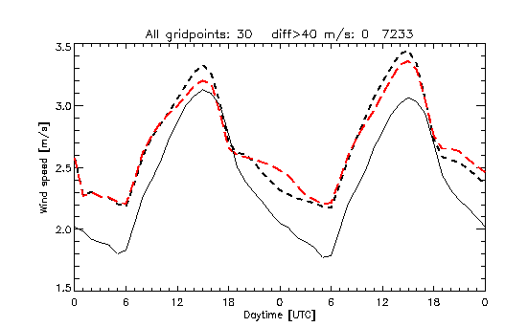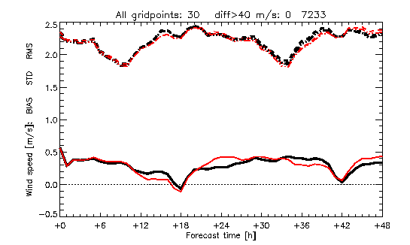
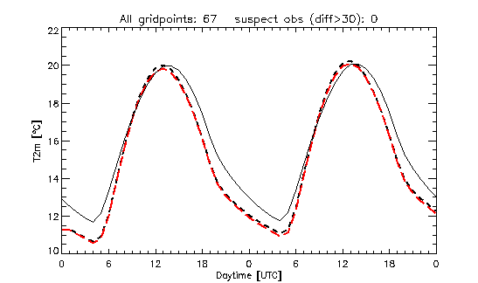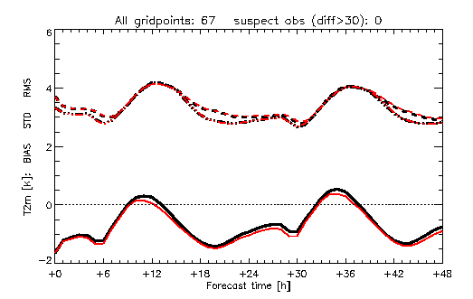
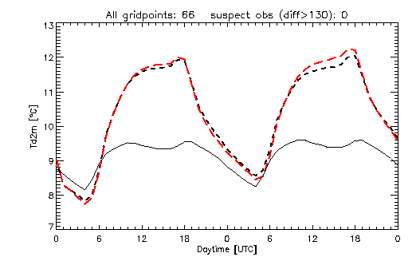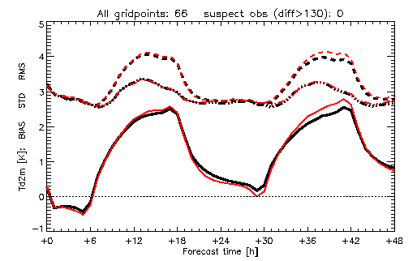
Figure 3: Like Figure 2, but for wind speed (upper panel), 2m-temperature (middle) and dew point (lower panel).

3. Conclusions and outlook

The test chain using the KF/B scheme is running since end of May. The results for June and July 2006 are compared to ANETZ measurements and results of the operational runs. Precipitation is overestimated in the simulations with both schemes. The KF/B test chain shows an even stronger overestimation than the operational run due to an overestimation of precipitation events below 2 mm/6h in flat regions. Further investigations will be performed in order to reduce this overestimation. The operational run strongly overestimates heavy precipitation events, especially for regions between 800m and 1500m height. The KF/B scheme significantly improves the diurnal cycle of precipitation in regions where precipitation is not predominantly affected by orography.

The quality of temperature, humidity and wind forecast is similar for the two convection schemes. Differences develop in cloud cover after 15 hours simulation time, when convection starts, and remain constant for the rest of the simulation. The simulation with KF/B has a cloud cover that is reduced by 0.5 octa compared to the operational runs. Since deviations from the measured cloud cover are similar, it’s not possible to decide which of the cloud covers is more realistic. The strongest deviations occur for high clouds. Further investigations will be performed in order to explain the difference.

The simulations with the KF/B scheme show an overestimation of convective precipitation in the first 3 hours of the simulation. This spin up effect is not caused the initial conditions taken from the assimilation with the Tiedtke convection scheme. The spatial distribution of precipitation is simulated correctly, but the amount of precipitation is too high in the first 3 hours. Further studies are carried out in order to avoid the spin up effect.

The test chain will be continued in order to study the effect of theKF/B scheme during autumn and winter season.

Literature:

Tiedtke, M. (1989): A comprehensive mass flux scheme for cumulus parameterization in large-scale models, Mon. Wea. Rev., Vol. 117, 1779-1800.
Bechtold, P.; Bazile, E.; Guichard, F.; Mascart, P. and Richard, E. (2001): A mass-flux convection scheme for regional and global models, Q. R. J. Meteorol. Soc., Vol. 127, 869-886.

